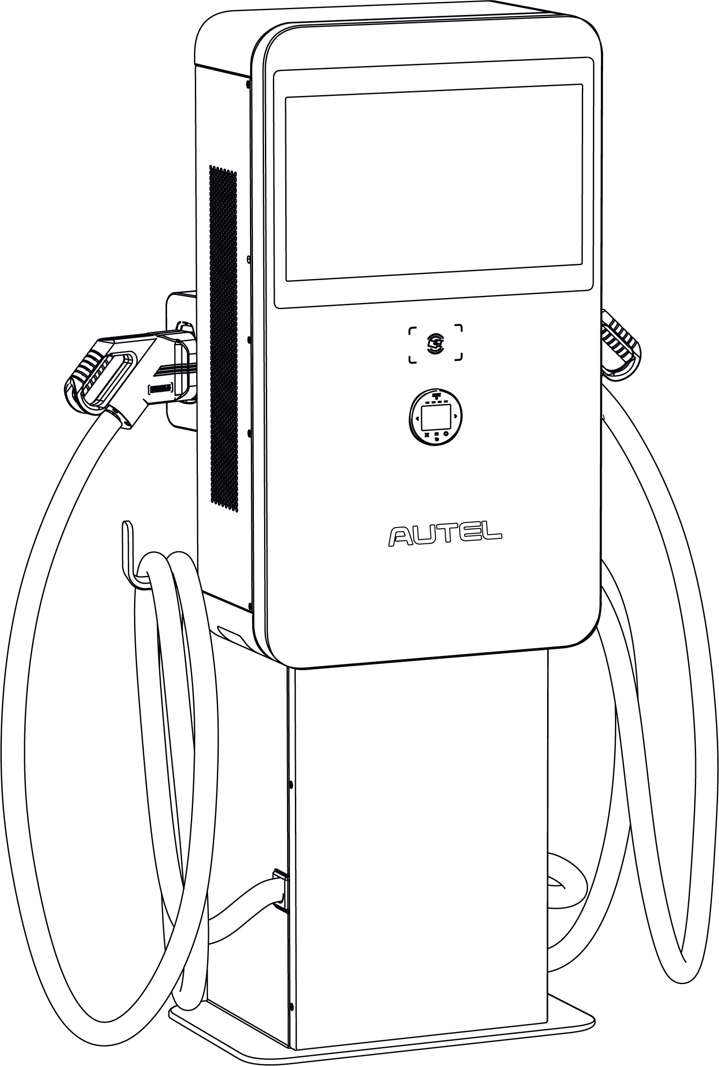

**Installation and Operation Manual**

MaxiCharger DC Wall Mount (EU)

Trademarks

Autel® and MaxiCharger® are trademarks of Autel Intelligent Technology Corp., Ltd., registered in China, the United States and other countries. All other marks are trademarks or registered trademarks of their respective holders.

Copyright Information

No part of this manual may be reproduced, stored in a retrieval system or transmitted, in any form or by any means, electronic, mechanical, photocopying, recording, or otherwise without the prior written permission of Autel.

Disclaimer of Warranties and Limitation of Liabilities

All information, specifications and illustrations in this manual are based on the latest information available at the time of printing.

Autel reserves the right to make changes at any time without notice. While information of this manual has been carefully checked for accuracy, no guarantee is given for the completeness and correctness of the contents, including but not limited to the product specifications, functions, and illustrations.

Autel will not be liable for any direct, special, incidental, indirect damages or any economic consequential damages (including the loss of profits).

**IMPORTANT**

Before operating or maintaining this unit, please read this manual carefully, paying extra attention to the safety warnings and precautions.

For Services and Support:

Web: www.autelenergy.com

Tel: +49 (0) 89 540299608 (Europe)

0086-755-2267-2493 (China)

Email: support.eu@autel.com

For technical assistance in all other markets, please contact your local selling agent.

**CONTENTS**

1 Using This Manual 1

1.1 Conventions 1

1.1.1 Bold Text 1

1.1.2 Signal Words 1

1.1.3 Hyperlinks 1

2 General Introduction 2

2.1 Safety Warnings 3

2.2 Product Overview (Outside) 4

2.3 Product Overview (Inside) 5

2.4 Technical Specifications 6

3 Preparation 9

3.1 Before You Begin 9

3.2 Location Requirements 9

3.3 Checking the Box 11

3.4 Installation Tools 15

4 Installation 16

4.1 Unpacking 16

4.2 Moving the MaxiCharger 17

4.3 Installing the MaxiCharger 19

4.3.1 Mounting on a Wall 19

4.3.2 Mounting on a Pedestal 26

4.3.3 Mounting on a Trolley 37

4.4 Power Supply Wiring 41

4.4.1 Opening the Door 42

4.4.2 Connecting the AC Input Cable 43

4.4.3 Powering on the MaxiCharger 45

4.5 Connecting the Ethernet Cable 46

4.6 Installing the SIM Card 47

4.7 Completing Installation 48

4.7.1 For Mounting on a Wall: 48

4.7.2 For Mounting on a Pedestal: 49

4.7.3 For Mounting on a Trolley (Individual Type): 50

4.8 Installing the Upstream Protective Device 51

4.9 Preparing for Commissioning 51

5 Operation 53

5.1 Charging Procedure 53

5.1.1 Standby Mode 53

5.1.2 Authorization 54

5.1.3 Start Charging 55

5.1.4 Charging 56

5.1.5 Stop Charging 57

5.1.6 Finish Charging 57

5.2 Charging Errors 58

5.2.1 Connector Connection Error 58

5.2.2 Authorization Failure 58

5.2.3 Charging Start Failure 58

5.2.4 Charging Failure 58

5.3 Powering down the MaxiCharger 58

5.3.1 Measuring the AC Voltage 59

5.3.2 Measuring the DC Voltage 60

5.4 Local Service Portal Operations 61

5.4.1 Setting the OCPP Parameters 61

6 Maintenance 62

6.1 Routine Maintenance 62

6.1.1 Residual Current Device Maintenance 62

6.1.2 Cleaning the MaxiCharger 63

6.1.3 Cleaning and Replacing the Filter 63

6.2 Inspection and Maintenance 64

6.3 Remote Maintenance 65

6.4 Maintenance Schedule 65

7 Troubleshooting and Service 66

7.1 Troubleshooting 66

7.2 Service 68

# Using This Manual

This manual provides the procedures for installing and operating of the MaxiCharger DC Wall Mount. Read through this manual and become familiarized with the instructions of the MaxiCharger prior to installation to ensure successful use.

Some illustrations shown in this manual may contain modules and optional equipment that are not included in your system. Contact your sales representative for availability of other modules and optional tools or accessories.

This document is intended for these groups:

* Owner of the MaxiCharger
* Installation Engineer

## Conventions

### Bold Text

Bold text is used to highlight selectable items such as buttons and menu options.

### Signal Words

* **NOTE**: provides helpful information such as additional explanations, tips, and comments.
* **IMPORTANT**: indicates a situation that, if not avoided, may result in damage to the test equipment or vehicle.
* **DANGER**: indicates an imminently hazardous situation which, if not avoided, will result in death or serious injury to the operator or bystanders.
* **WARNING**: indicates a potentially hazardous situation which, if not avoided, could result in death or serious injury to the operator or to bystanders.
* **CAUTION**: indicates that disobeying the instruction can cause damage to the equipment or property.

### Hyperlinks

Hyperlinks are available in electronic documents. Blue italic text indicates a selectable hyperlink and blue underlined text indicates a website link or an email address link.

# General Introduction

The Autel MaxiCharger is designed to charge an electric vehicle (hereinafter called EV). Our chargers provide you with safe, reliable, fast, and smart charging solutions.

The MaxiCharger is intended for the DC charging of EVs and is intended for both indoor and outdoor use:

* Fleets
* Highway rest stops
* Commercial parking garages
* Other locations

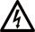**DANGER**

* Do not operate the equipment in any other ways than described in this manual or other related documents. Not following the instructions may cause potential personal injury and/or damage to the property.
* Use the MaxiCharger only as intended.

**NOTE**

The images and illustrations depicted in this manual may slightly differ from the actual product.

This manual will instruct you how to install and operate the MaxiCharger.

## Safety Warnings

* Disconnect the power supply to the MaxiCharger during the entire installation procedure.
* The load capacity of the grid must meet the requirements of the MaxiCharger.
* Connect the MaxiCharger to a grounded, metal, permanent wiring system. Otherwise, use the equipment-grounding conductor with the circuit conductors and connect it to the equipment grounding terminal or lead on the product.
* Unqualified personnel must keep a safe distance during the entire installation procedure.
* The connections to the MaxiCharger must comply with all applicable local rules.
* Only use electrical wires of sufficient gauge and insulation to handle the rated current and voltage demand.
* Protect the wiring inside the MaxiCharger from damage and do not obstruct the wiring when you perform maintenance on the cabinet.
* Keep the cabinet away from all water source.
* Protect the MaxiCharger with safety devices and measures as specified by local rules.
* Wear proper personal protective equipment such as protective clothing, safety gloves, safety shoes, and safety glasses when necessary.

## Product Overview (Outside)

1. 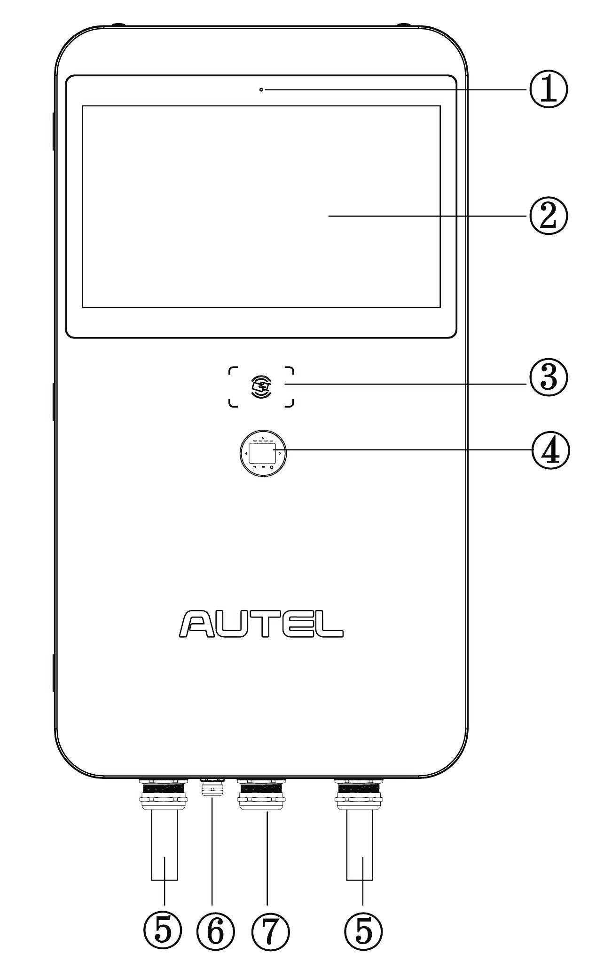Light Sensor
2. Touchscreen
3. RFID Card Reader
4. POS Payment Device (optional)
5. EV Charging Cable
6. Ethernet Cable Port
7. AC Inlet Hole
8. Vent — each on the right and left side
9. Slot
10. Groove
11. Bezel
12. Lifting Handle

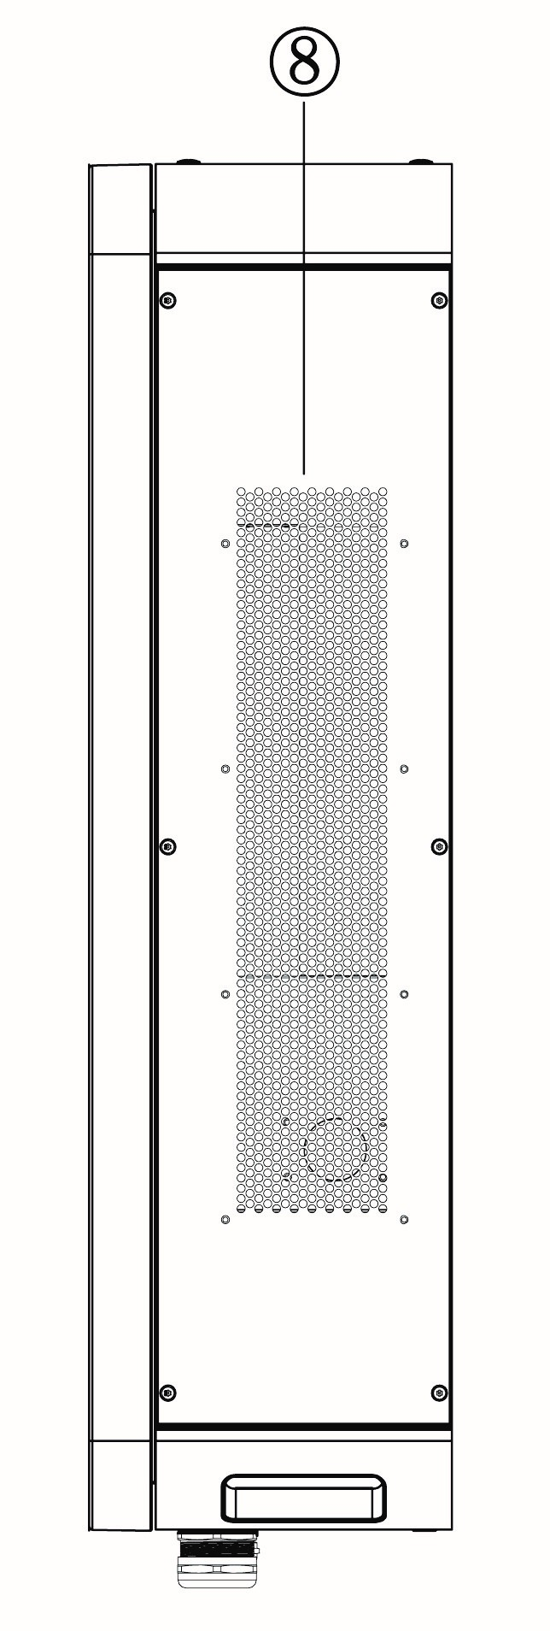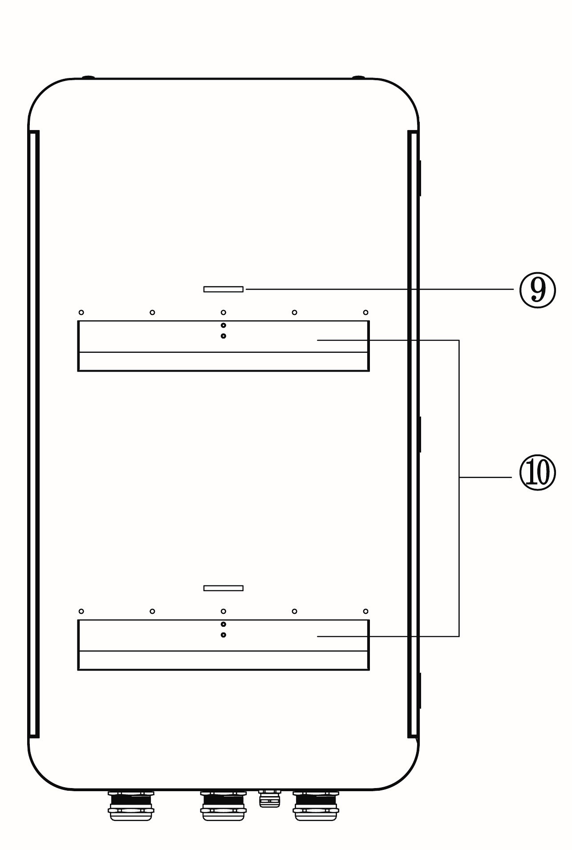

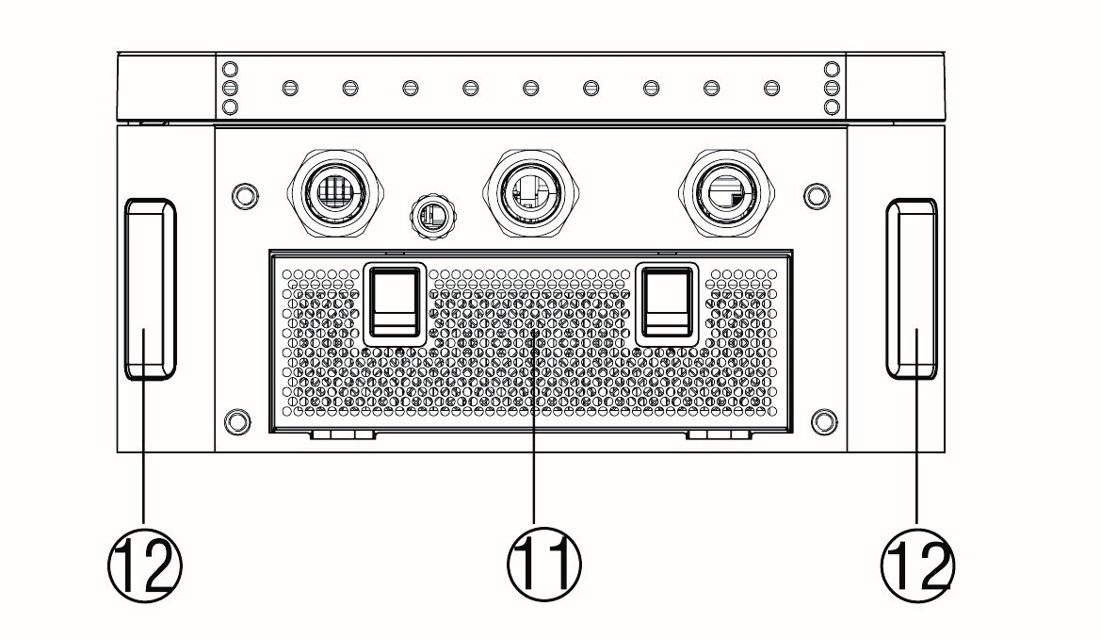

## Product Overview (Inside)

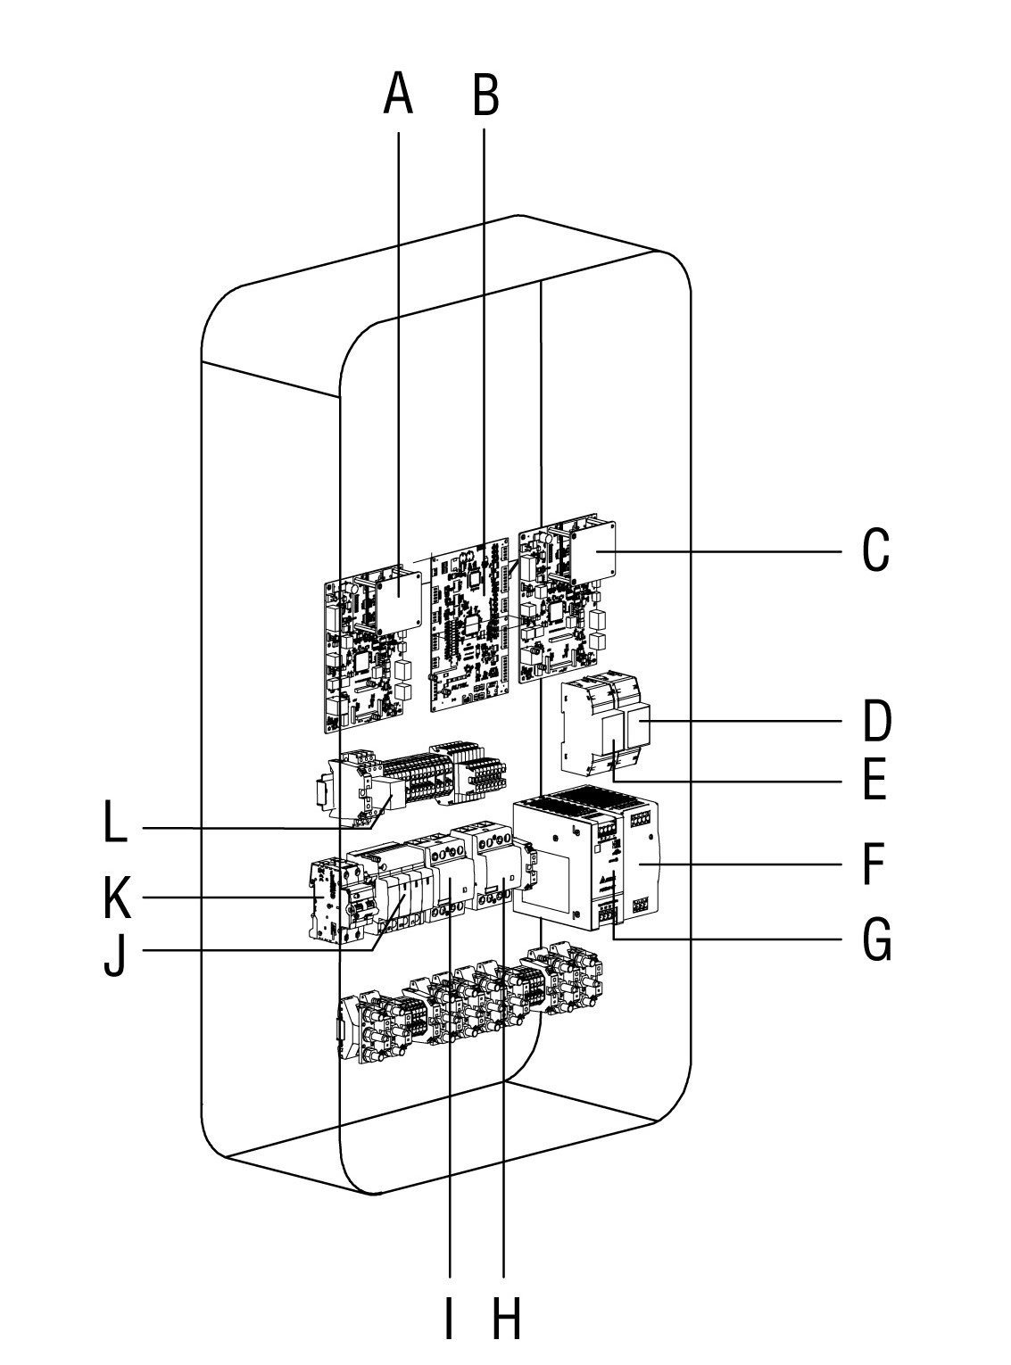

|  |
| --- |
| 1. Inertial Measurement Unit 1 |
| 1. Electronic Control Unit |
| 1. Inertial Measurement Unit 2 |
| 1. Energy Meter (PJ1) |
| 1. Energy Meter (PJ2) |
| 1. 48 V Auxiliary Power |
| 1. 24 V Auxiliary Power |
| 1. AC Contactor (KM2) |
| 1. AC Contactor (KM1) |
| 1. Surge Protection Device |
| 1. Fuse |
| 1. Intermediate Relay |

## Technical Specifications

| Item | Description |
| --- | --- |
| **Product Information** | |
| **Power Rating** | 40 kW, max. 47 kW |
| **Charging Type** | Fast power charging |
| **Max. Output Current for Outlet A/B** | * CCS2: 133 A * CHAdeMO: 125 A |
| **Outlet A+B** | * CCS2 + CHAdeMO (charging for 2 EVs concurrently) * CCS2 + CCS2 (charging for 2 EVs concurrently) * CCS2 |
| **Rated/Max. Input AC Current** | 75 A/82 A |
| **Input Voltage Range** | 400 VAC +10% ~ -10% @ 50Hz |
| **Network Type** | * TN-S (Requires external RCD) * TN-C (Requires external RCD) * TN-C-S (Requires external RCD) * TT (Requires external RCD) |
| **AC Input Connection** | 3P + N + PE |
| **DC Output Voltage** | * CCS2: 150 ~ 950 VDC * CHAdeMO: 150 ~ 500 VDC |
| **Cable Length** | 4 m/5 m |
| **Protection** | Overcurrent, overvoltage, under-voltage, ground fault, over-temperature, short-circuit, insulation monitor, surge protection |
| **Overvoltage Category** | AC side (Input) OVC: III |
| **Power Factor (>50% load)** | >= 0.99 |
| **Total Harmonic Distortion**  **(>50% load)** | <= 5% |
| **Peak Efficiency** | >= 96% |
| **Standby Power** | 40 W |
| **Cellular Communication** | GSM/4G/LTE |
| **General Characteristics** | |
| **Enclosure Type** | Stainless steel 430 |
| **Operating Altitude** | < 2000 m (2000 m ~ 3000 m with power de-rating) |
| **Operating Temperature Range** | -30 °C to +55 °C (+45 °C to +55 °C with linear power de-rating) |
| **Storage Temperature Range** | -40 °C to +70 °C |
| **Mounting** | Free-standing cabinet |
| **Dimensions (W x D x H)** | 550 x 265 x 1000 mm |
| **User Interface** | |
| **Status Indication** | LED/APP |
| **User Interface** | * Autel Charge APP * Autel Charge Cloud |
| **Connectivity** | * Wi-Fi * Ethernet * CAN * RS485 |
| **Communication Protocols** | * OCPP 1.6 JSON * OCPP 2.0.1 (optional) |
| **User Authentication** | * QR code * RFID * ISO 15118 Plug & Charge * Credit card (optional) |
| **Software Update** | |
| **Software Update** | OTA updates via web portal |
| **Certification and Standards** | |
| **Charging System** | * IEC 61851-1 * IEC 61851-23 * IEC 61851-21-2 |
| **Communication to the EV** | * ISO 15118 PnC * DIN 70121 * CHAdeMO 1.2 |
| **EMC Compliance** | Class A |
| **Certification** | * CE * UKCA * TR25 |
| **Design Life** | 10 year |
| **Warranty** | Base warranty 24 months after site acceptance test or 30 months after factory delivery. Warranty extensions available |

# Preparation

## Before You Begin

* Read through this manual prior to installation to be familiarized with the installation steps.
* Ensure the appropriate wiring, circuit protection, and metering are in place at the installation site, according to the specifications, wiring diagrams, and grounding requirements.
* Ensure the MaxiCharger is connected to a grounded, metal, permanent wiring system. Otherwise, an equipment-grounding conductor must be run with the circuit conductors and connected to the equipment grounding terminal or lead on the product.
* Ensure the installation site has a load capacity sufficient to support the MaxiCharger.
* If you choose to use a cellular network to communicate with the MaxiCharger, the cellular coverage at the installation site should be consistently strong. Use a cellular signal detection device to ensure the signal is above -90 dBm. If the signal is below -90 dBm, install repeaters to boost the strength of the cellular signal. Repeaters are often required when installing the MaxiCharger in underground environments such as in an underground garage or enclosed parking space.
* There is enough space available around the installation site to use a lifting equipment, to unpack, and to allow people to work freely.

## Location Requirements

The MaxiCharger supports three available mounting options:

* Mounting on a wall
* Mounting on a pedestal
* Mounting on a trolley

The location requirements will vary among mounting options. Before mounting the MaxiCharger, choose a suitable mounting location that meet the following requirements:

**For mounting on a wall**:

* The mounting location must be capable of supporting the MaxiCharger. The maximum weight of a MaxiCharger is approximately 123 kg.
* The wall must be flat and plumb.
* Ensure the charging connector of the MaxiCharger can sufficiently reach the vehicle’s charging port with the chosen cable length. The standard charging cable length is 4 m, and a 5-meter cable is also available.

**For mounting on a pedestal**:

* To safely mount a MaxiCharger, the concrete must be at least 80 mm thick.
* The concrete surface must be perfectly flat and level.
* Ensure the charging connector of the MaxiCharger can sufficiently reach the vehicle’s charging port with the chosen cable length. The standard charging cable length is 4 m, and a 5-meter cable is also available.
* If a new foundation is needed, prepare one according to the recommended dimensions (600 mm x 420 mm x 100 mm) (L x W x H).

**NOTE**

The foundation is recommended to be level with the ground surface.

## Checking the Box

Depending on your order, ensure the corresponding items can be found in the package:

**Main Body Kit**

|  |  |  |  |
| --- | --- | --- | --- |
| **MaxiCharger** |  | **Lifting Eye Bolt (M12)**  (4 PCS) |  |
| **Torx Screwdriver (T25)** |  | **Hex Key (6 mm)** |  |
| **Screw (M5 x 20) (For spare use)**  (4 PCS) |  |  |  |

**Wall Dock Kit (Optional)**

|  |  |  |  |
| --- | --- | --- | --- |
| **Wall Dock** |  | **Holster Front Cover**  (2 PCS) |  |
| **Holster Rear Cover**  (2 PCS) |  | **Expansion Bolt (M12 x 80)**  (4 PCS) |  |
| **Expansion Bolt (M6 x 60)**  (8 PCS) |  |  |  |

**Pedestal Kit (Individual Type) (Optional)**

|  |  |  |  |
| --- | --- | --- | --- |
| **Pedestal** |  | **Expansion Bolt (M12 x 80** **)**  (4 PCS) |  |
| **Screw (M12 x 30)**  **(2 PCS for spare)**  (4 PCS) |  | **Drilling Template** |  |

**Trolley Kit (Individual Type) (Optional)**

|  |  |  |  |
| --- | --- | --- | --- |
| **Main Unit** |  | **Industrial Plug** |  |
| **Screw (M12 x 30)**  (2 PCS) |  |  |  |

**MaxiCharger with Pedestal Kit (Integrated Type)**

|  |  |  |  |
| --- | --- | --- | --- |
| **Main Unit** |  | **Lifting Eye Bolt (M12)**  (4 PCS) |  |
| **Torx Screwdriver (T25)** |  | **Hex Key (6 mm)** |  |
| **Expansion Bolt (M12 x 80** **)**  (4 PCS) |  | **Screw (M5 x 20) (For spare use)**  (4 PCS) |  |
| **Drilling Template** |  |  |  |

**MaxiCharger with Trolley Kit (Integrated Type)**

|  |  |  |  |
| --- | --- | --- | --- |
| **Main Unit** |  | **Industrial Plug** |  |
| **Torx Screwdriver (T25)** |  | **Hex Key (6 mm)** |  |
| **Screw (M5 x 20) (For spare use)**  (4 PCS) |  |  |  |

## Installation Tools

* Flathead Screwdriver
* Hoisting Equipment
* Spirit Level
* Marker/Pencil
* Socket Wrench (10 mm/13 mm/19 mm)
* Drill (16 mm/10 mm)
* Cleaning Tool
* Wire Stripper
* Cable Lug
* Voltage Tester
* Digital Multimeter

**NOTE**

* The tools mentioned above are not provided. Be sure to have all the tools prepared prior to the installation.
* This tool list does not necessarily include all the tools you may need.

# Installation

**General Installation Procedures:**

1. Unpack the shipping crate.
2. Move the MaxiCharger to the installation site.
3. Mount the MaxiCharger.
4. Complete the power supply wiring.
5. Complete Installation.

****The installation work shall be carried out after a suitable location is chosen.

**CAUTION**

* Cut off the power supply before opening the MaxiCharger.
* Do not touch the inside components of the MaxiCharger while it is powered on.
* Ensure no voltage is applied while checking the MaxiCharger.
* Operate the MaxiCharger only when its door is closed and locked.

## Unpacking

**NOTE**

The unpacking operation should be performed by an installation engineer.

1. Check the tilt and inversion indicators and shock watch.

* Observe the sensors attached to the wooden box for the degree of the tilt and complete overturn. If the sensors demonstrate severe tilt (over 30°) or total overturn as shown, refuse the delivery.

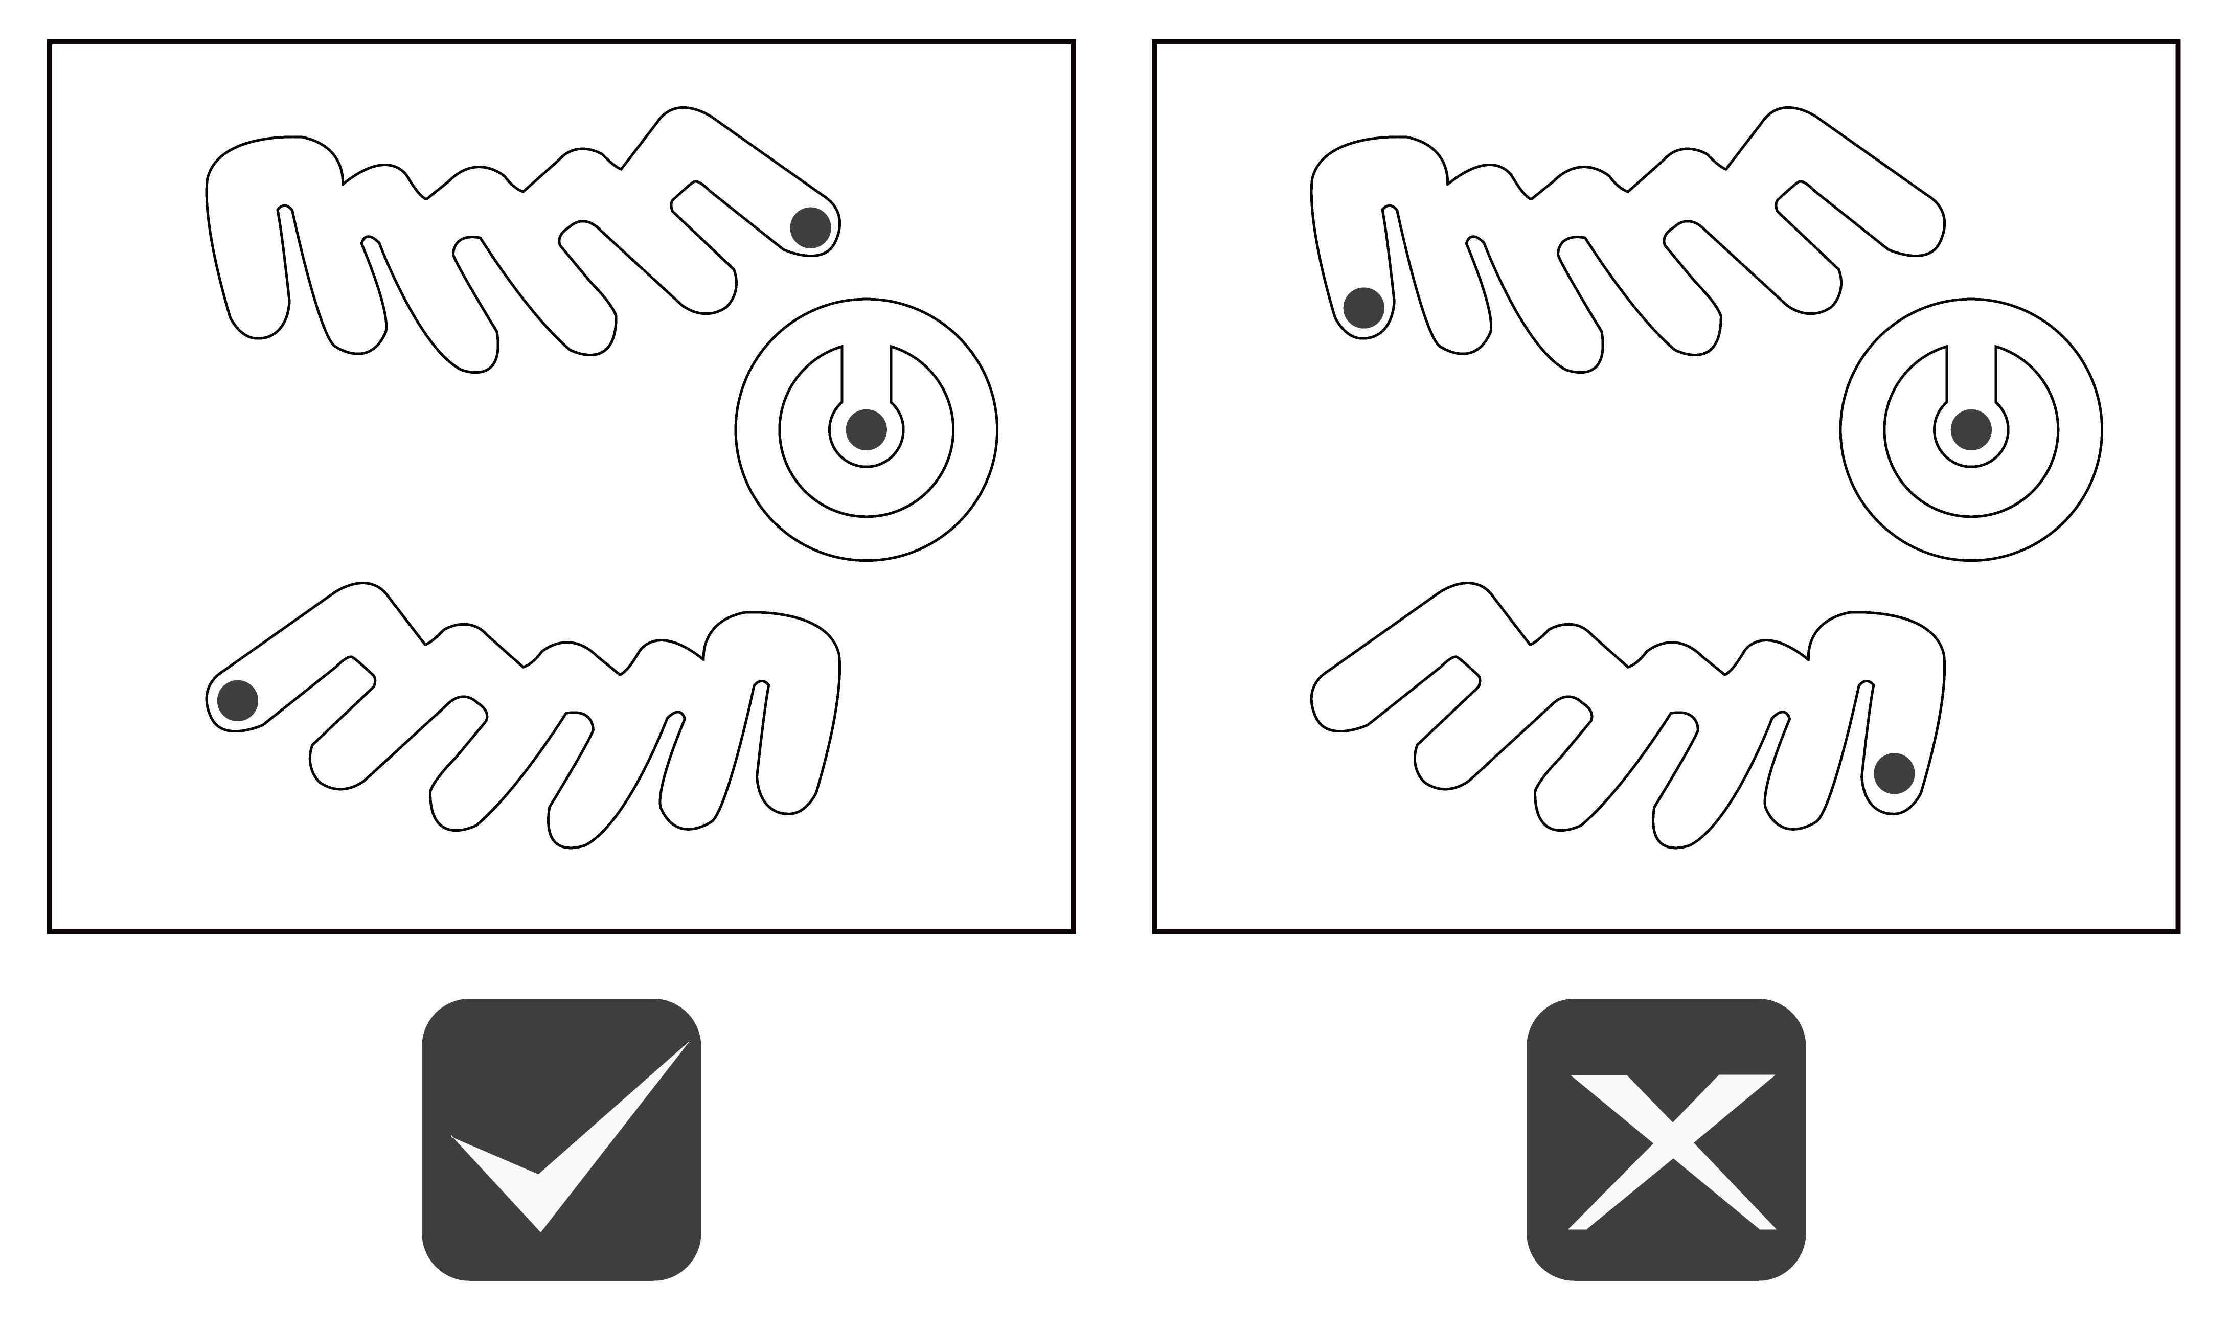

* If the shock watch appears red, contact Autel customer service and the delivery personnel, and then inspect the product for any damage. Do not accept the delivery until the inspection is complete and no damage is found.

1. Remove the packaging material and interior protection materials using appropriate tools.
2. Inspect whether the MaxiCharger and the parts for installation are damaged. If any damage is found or the parts are not consistent with the order, contact your local dealer.
3. Make sure that all parts are delivered according to the order.

## Moving the MaxiCharger

**NOTE**

The MaxiCharger with trolley (integrated type) skips this Chapter **4.2**.

It is recommended to move the MaxiCharger to the installation site using an appropriate hoisting equipment (crane, straps, and so on).

1. Remove the four screws on the top of the charger using a flathead screwdriver. Set them aside.

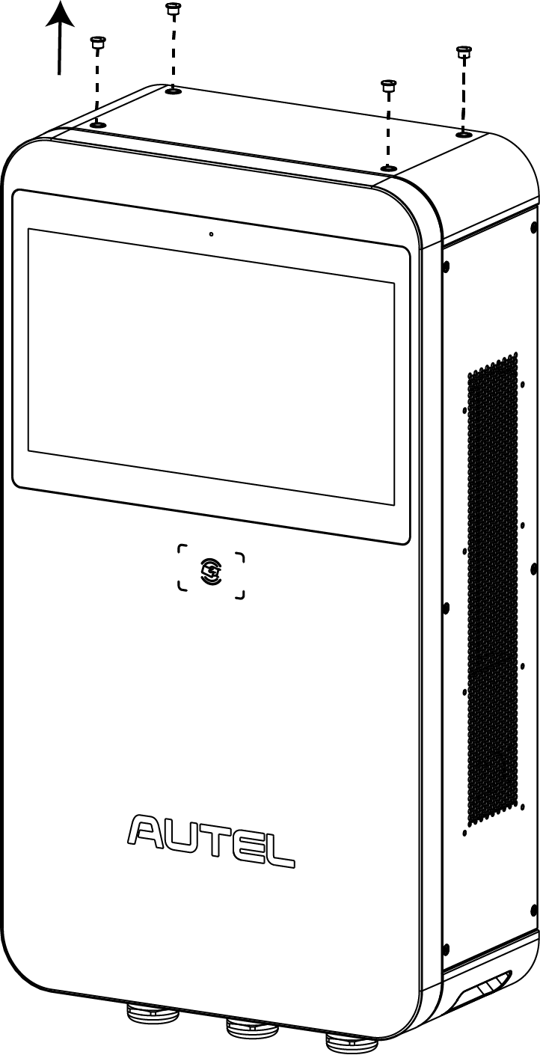

1. Install and tighten the four M12 lifting eye bolts into the four holes.
2. Connect the cables of the hoisting equipment to the eye bolts’ lifting loops. Note that the angle should be less than 45°, as shown below.
3. Move the MaxiCharger to the installation site.

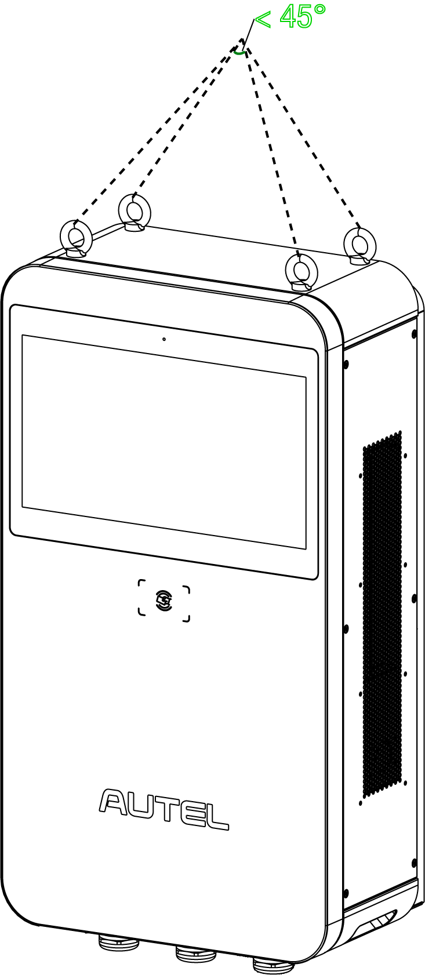

## Installing the MaxiCharger

### Mounting on a Wall

**IMPORTANT**

Always check local codes to ensure compliance. The guidelines described here are the minimum requirements. Ensure that the installation complied with all applicable codes.

***Step 1: Mounting the MaxiCharger***

1. Place the wall dock against the wall, 860 mm above the ground and level it using a spirit level.

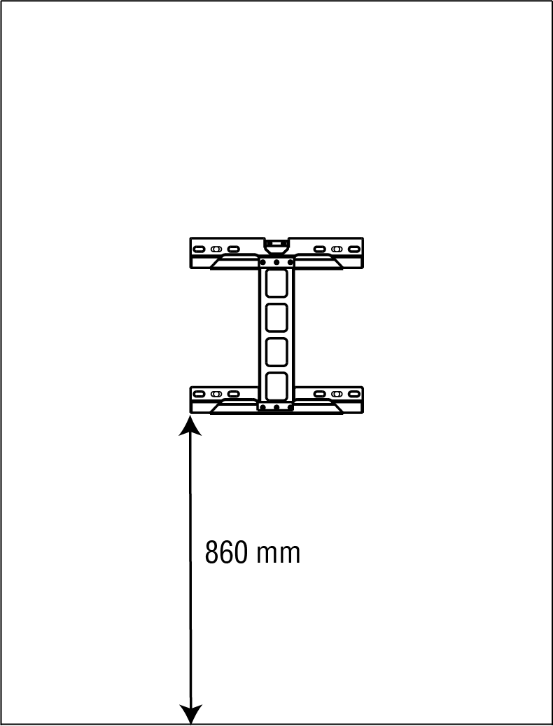

1. Mark the four holes on the wall and set the wall dock aside.

**NOTE**

There are three types of mounting holes on the wall dock: the outer, the middle, and the inner. Choose the most appropriate type based on the wall width. For instance, a narrow wall can use the inner mounting holes.

1. Drill four holes at the marked location measuring 16 mm in diameter and more than or equal to 80 mm in depth.

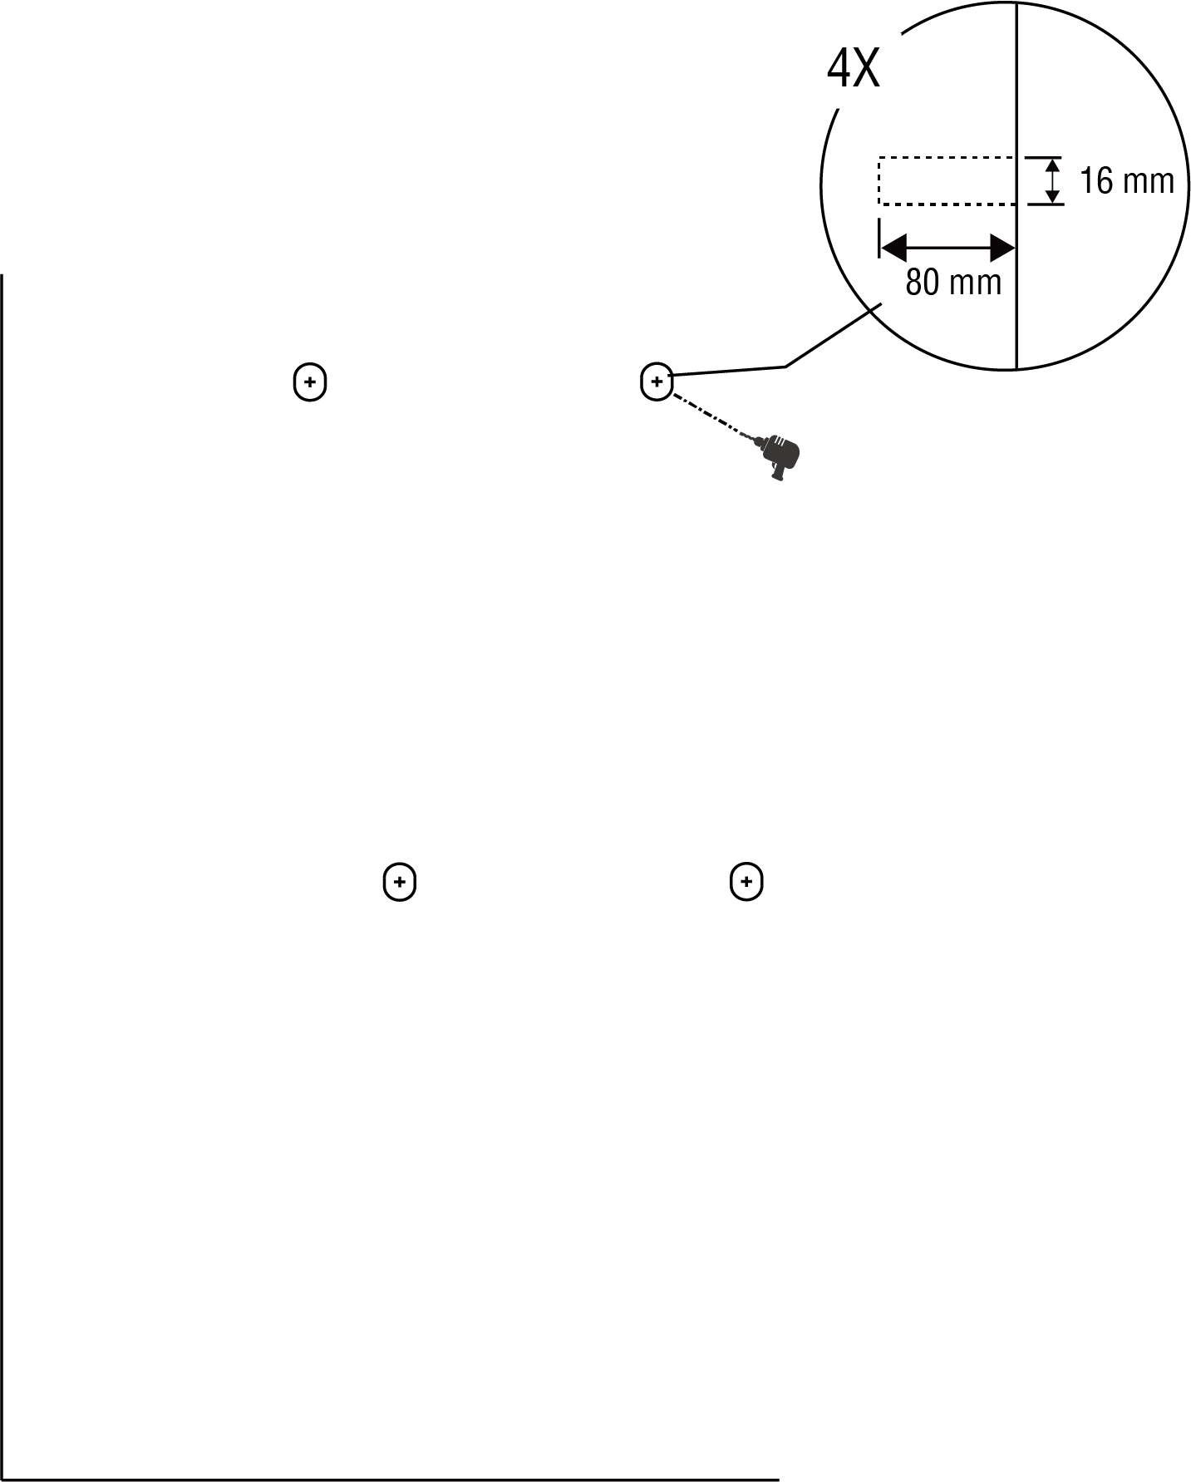

1. Tap the four M12 x 80 expansion bolts into the drilled holes. Remove the threaded bolts (**B**), ~~spring washers~~ (**C**), and flat washers (**D**) when the expansion sleeves (**A**) are stuck. Set them aside.

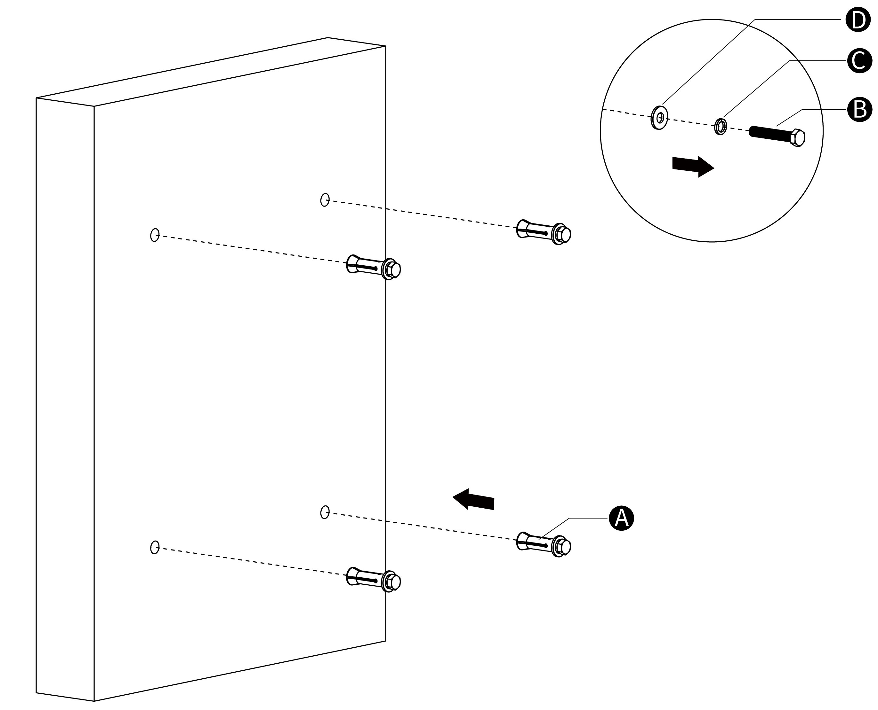

1. Attach the wall dock to the mounting location.
2. Reinsert the flat washers, spring washers, and threaded bolts in order and tighten them using a 19 mm socket wrench to the torque 45–55 N·m to secure the wall dock.

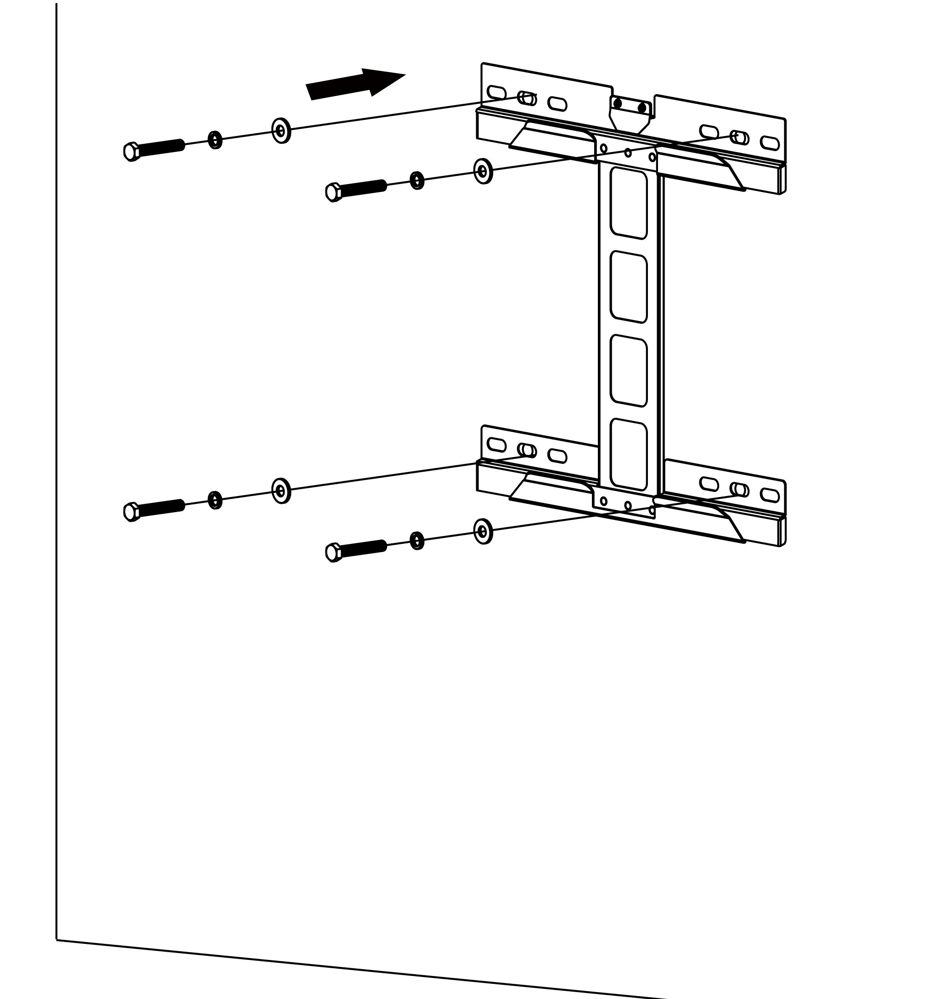

1. Lift the MaxiCharger onto the wall dock by the hoisting equipment. Position the slot (**B**) on the back of the MaxiCharger to fit the metal plate (**A**) of the wall dock as shown below. Meanwhile, the protrusion (**C**) on the wall dock and the groove (**D**) on the back of the charger will be fitted as well. Ensure the charger is securely attached.

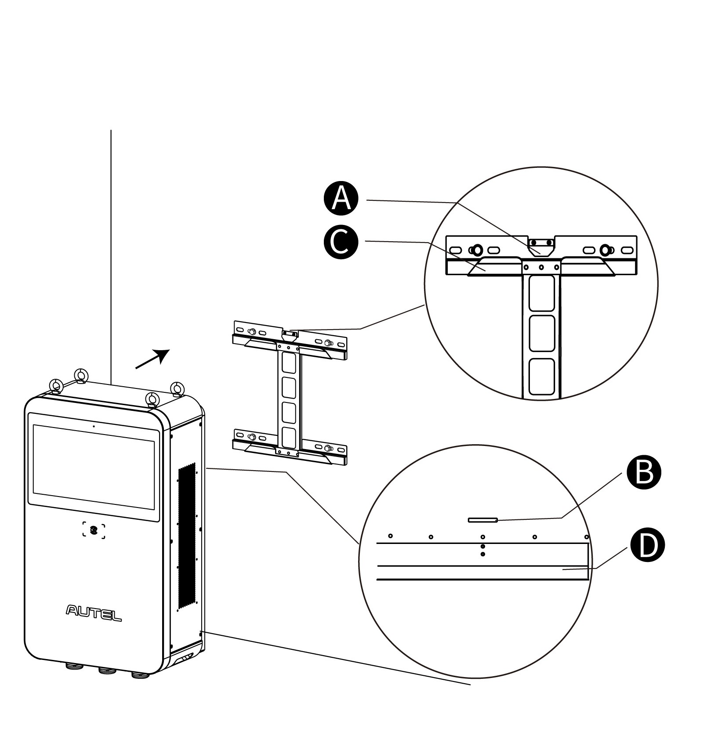

1. Remove the four lifting eyebolts and reinstall the top screws.

***Step 2: Mounting the Holsters***

1. Place the holster rear covers against the wall, 1040 mm above the ground and 300 mm from the MaxiCharger.
2. Mark eight mounting holes on the wall. Remove the holster rear covers temporarily.

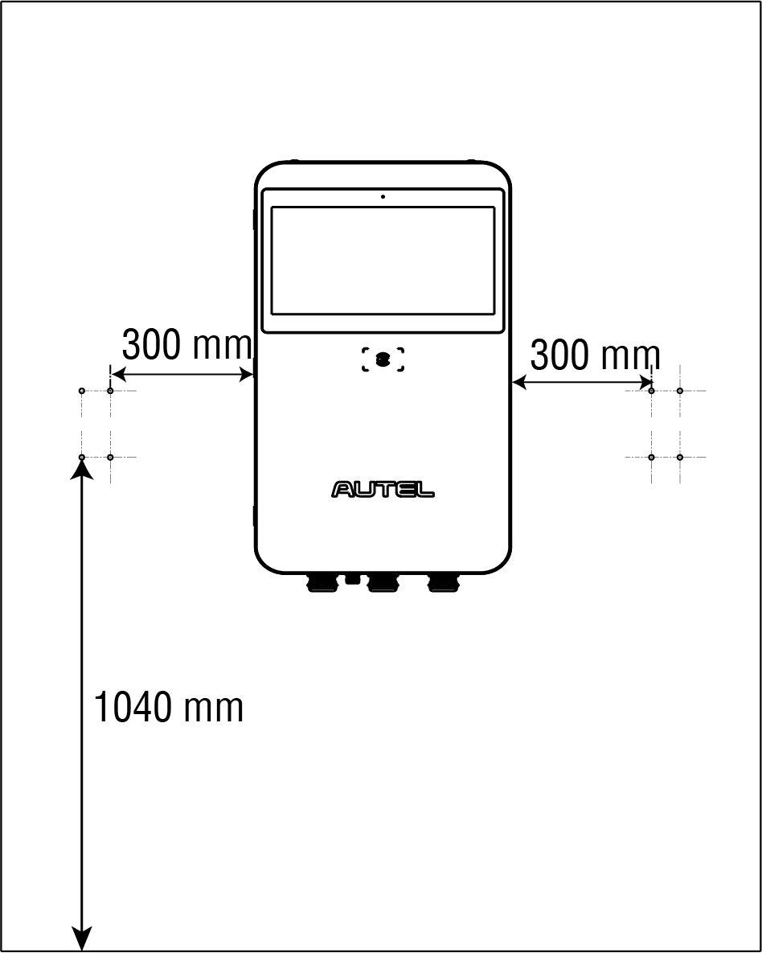

1. Drill the eight holes at the marked positions measuring 10 mm in diameter and 60 mm in depth.
2. Attach the holster rear covers to the drilled location by screwing the eight M6 x 60 expansion bolts into the holes. Tighten the screws to 3 N•m using a 10 mm socket wrench.
3. Position the holster front covers and press down forcefully to secure them.

**NOTE**

The front cover marked A is intended to install on the left and the other mark B is on the right.

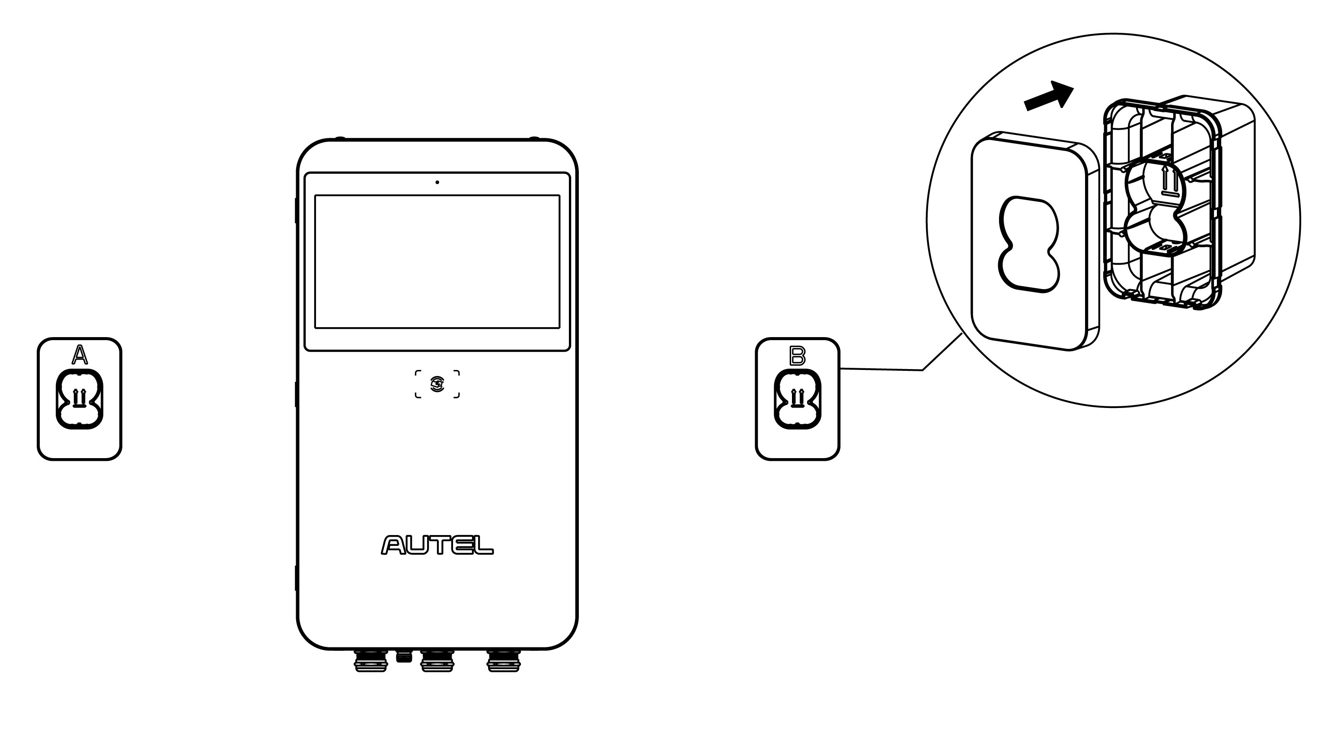

### Mounting on a Pedestal

The MaxiCharger with pedestal can be delivered in individual or integrated type. Follow the corresponding installation procedures depending on your order.

**IMPORTANT**

Always check local codes to ensure compliance. The guidelines described here are the minimum requirements. Ensure that the installation complied with all applicable codes.

#### Individual Type

***Step 1: Preparing a conduit***

1. Trench and excavate a cable tunnel to accommodate the conduit.
2. The conduit stub-up should be minimum 100 mm.
3. Pull the conduit and wire up through the exit opening, leaving 600 mm flexible length for the remaining installation activities.

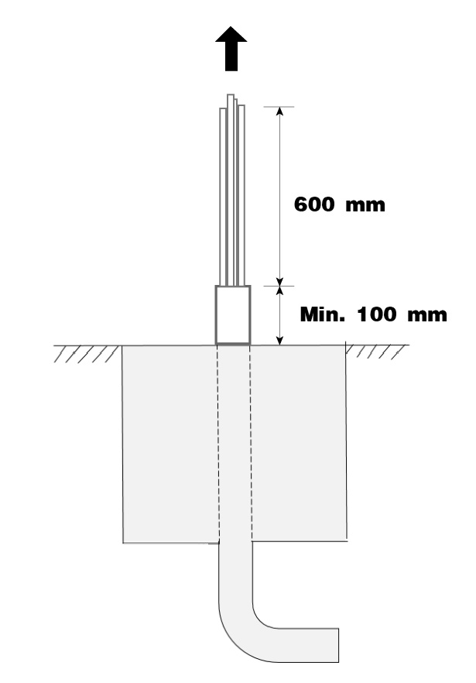

***Step 2: Drilling holes***

1. Place the drilling template on the concrete surface, aligning its central hole with the exit opening.

**NOTE**

The side with a “Front” sign on the drilling template must be placed in the front.

1. Mark four holes on the concrete surface using a marker. Remove the drilling template.
2. Drill the four holes at the marked positions measuring 16 mm in diameter and 80 mm in depth.
3. Clean the dust ashes.

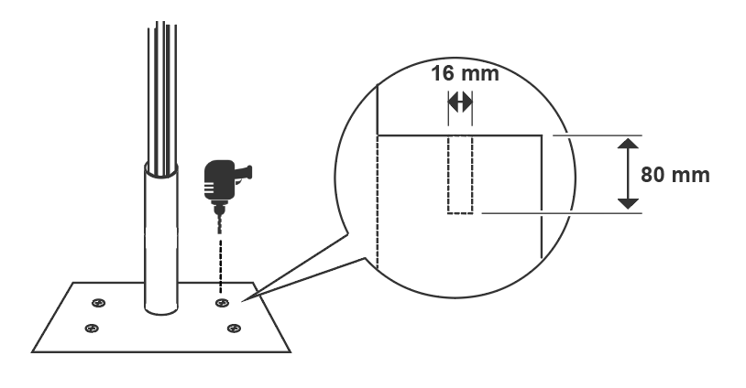

***Step 3: Mounting a pedestal***

1. Tap the four M12 x 80 expansion bolts into the four drilled holes. Remove the threaded bolts (**B**), spring washers (**C**), and flat washers (**D**) when the expansion sleeves (**A**) are stuck. Set them aside.

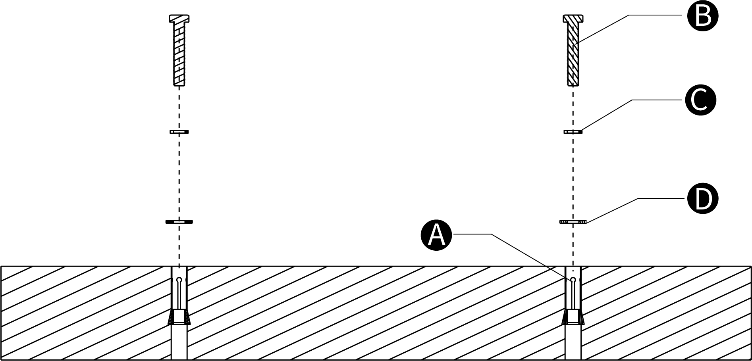

1. Loosen the four M5 x 12 screws using the T25 Torx screwdriver to remove the front cover from the pedestal. Set them aside.

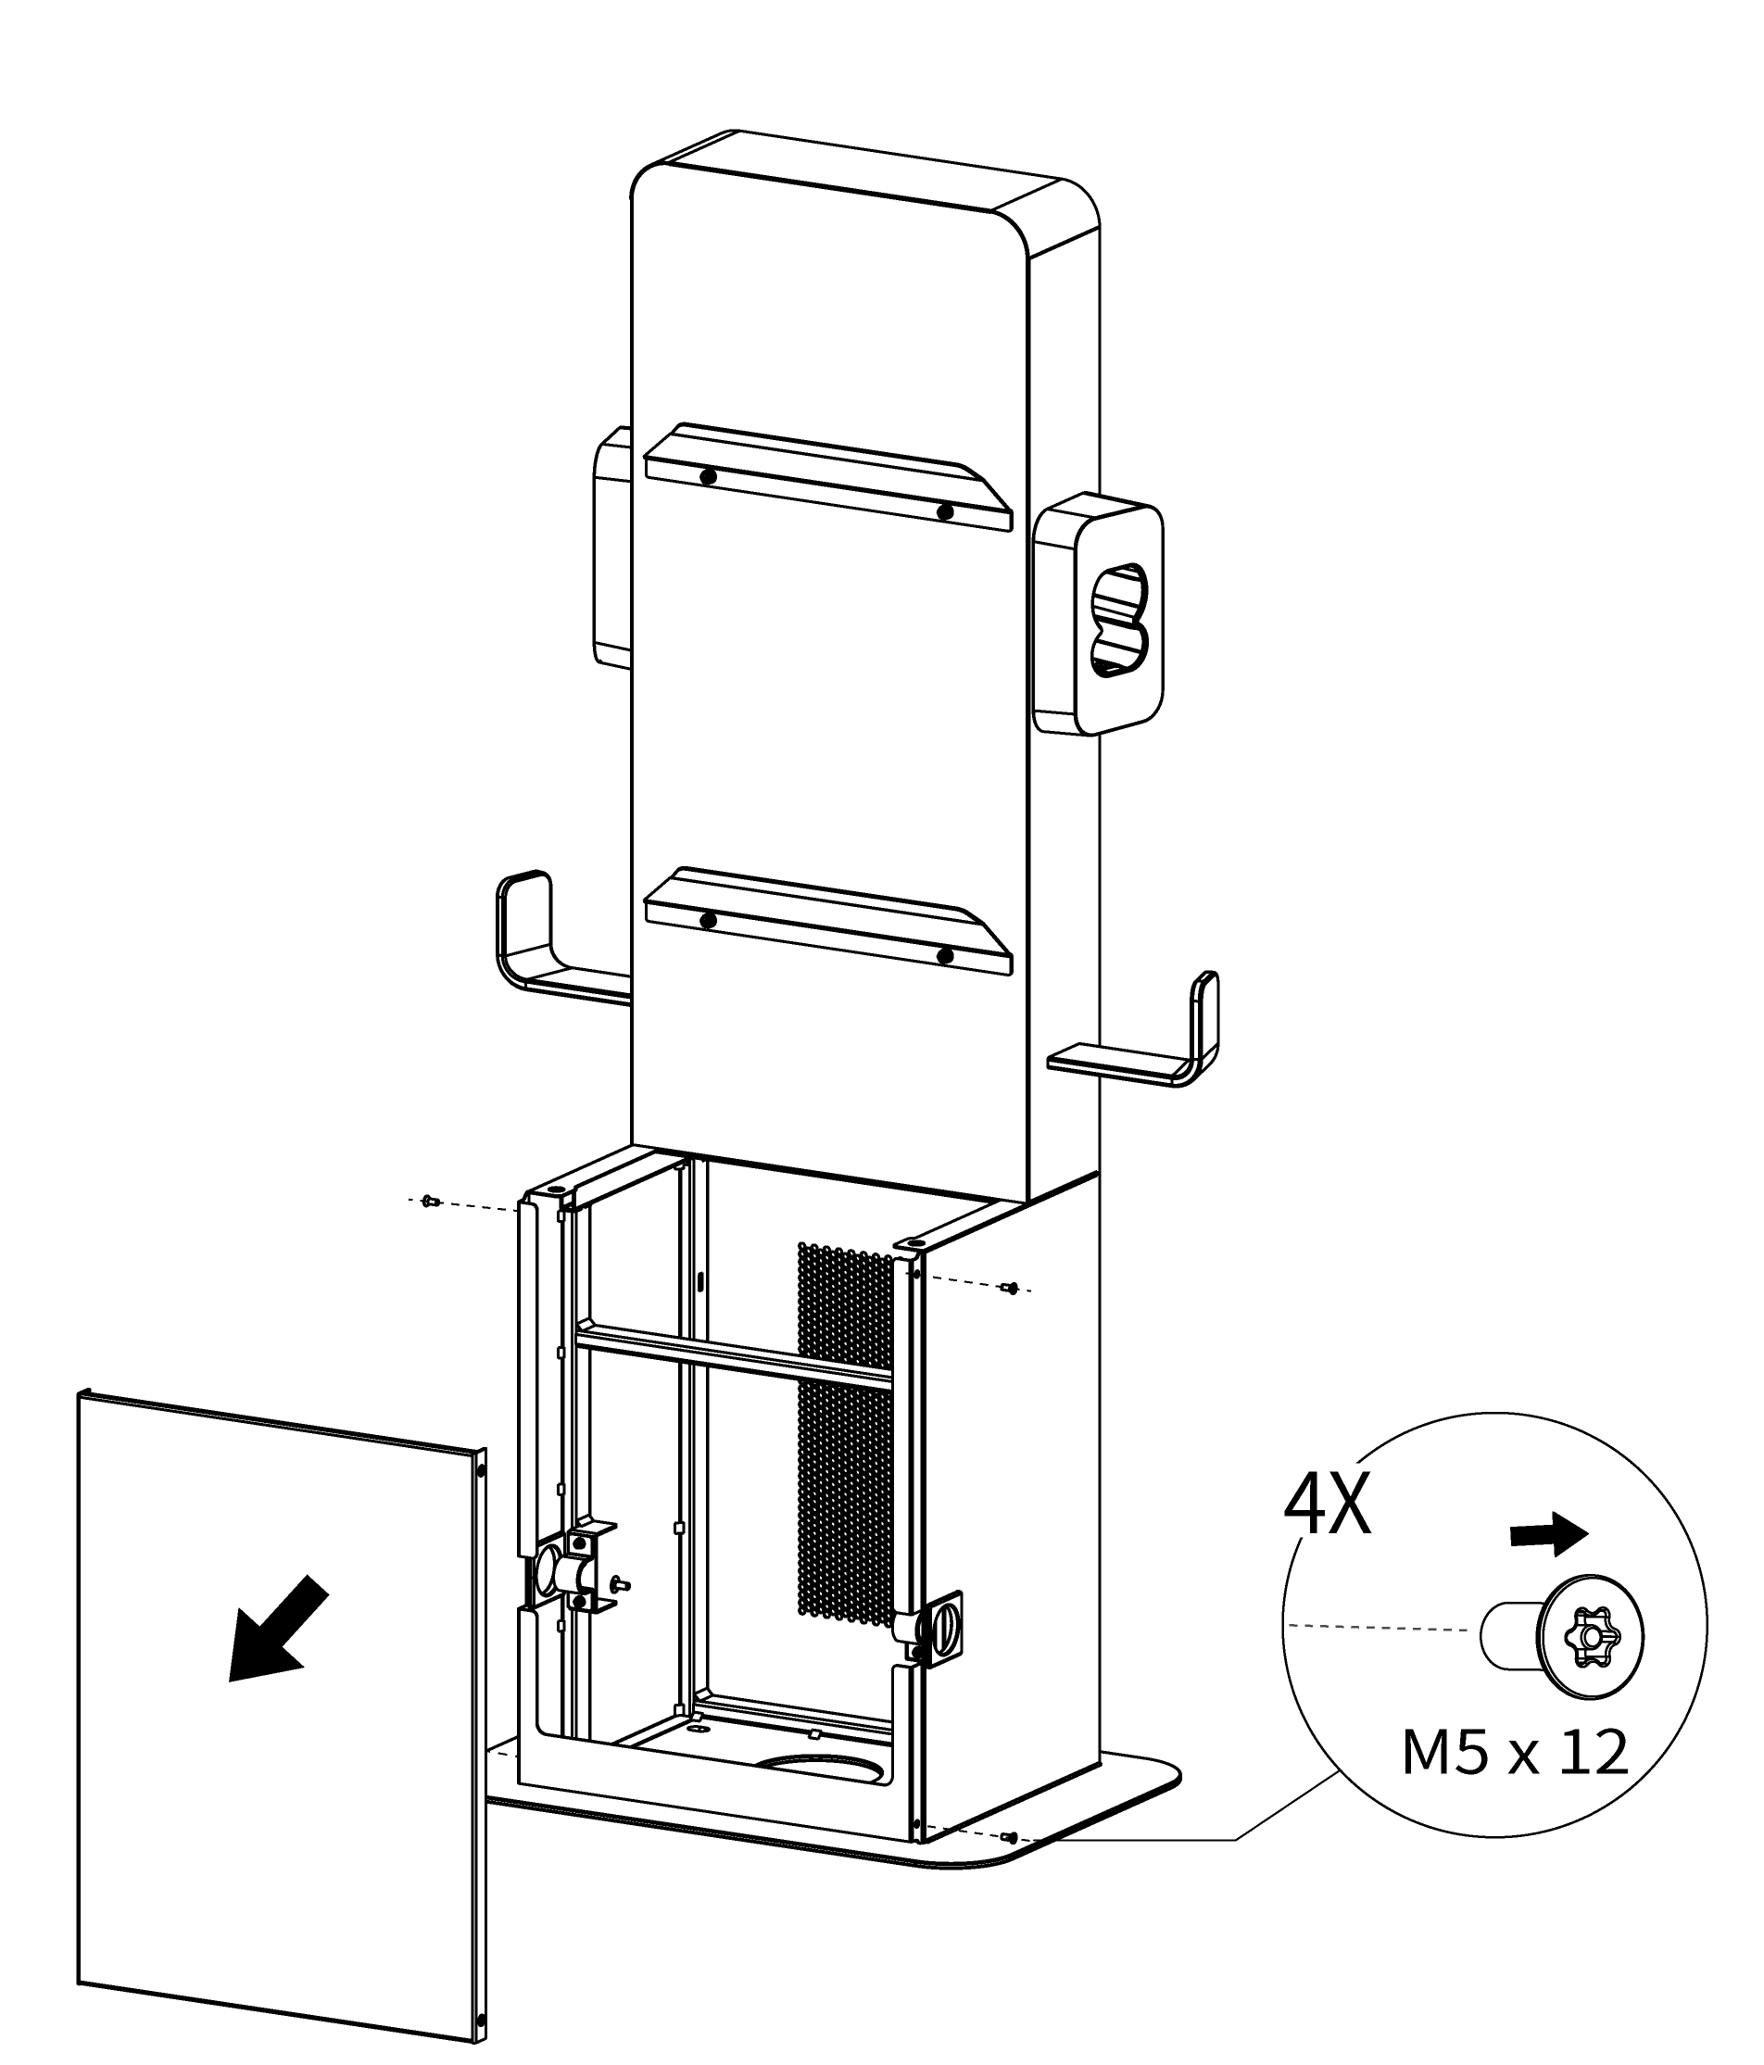

1. Place the pedestal onto the mounting location.
2. Reinsert the flat washers, spring washers, and threaded bolts in order and tighten them using a 19 mm socket wrench to 45–55 N·m.

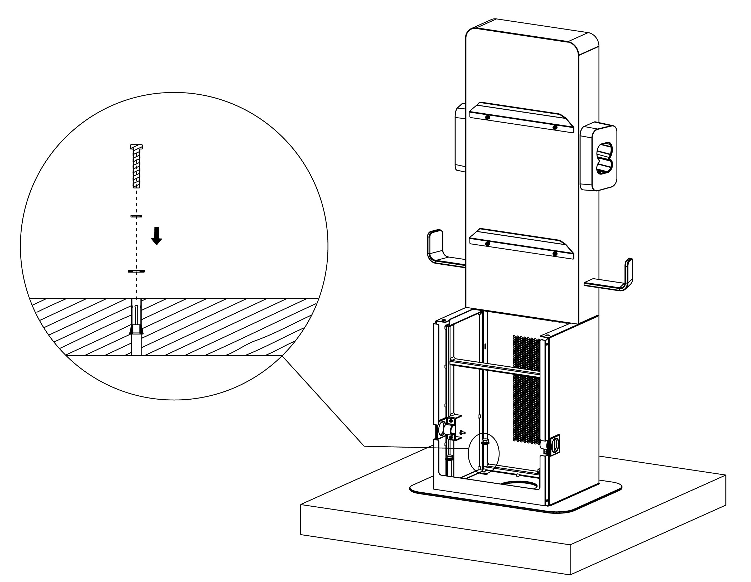

***Step 4: Mounting a MaxiCharger***

1. Lift the MaxiCharger onto the pedestal by the hoisting equipment. Position the groove (**B**) on the back of the MaxiCharger to fit the protrusion (**A**) of the pedestal as shown below. Ensure the charger is securely attached.

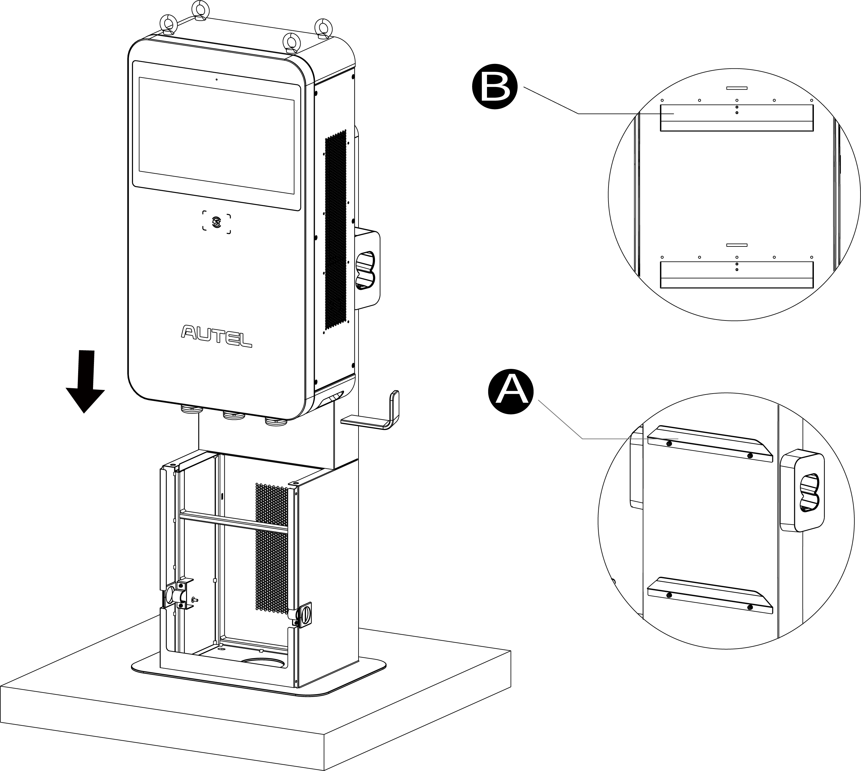

1. Insert and fasten the two M12 x 30 screws to the bottom holes (**A**) of the MaxiCharger using a 19 mm socket wrench to secure the MaxiCharger.

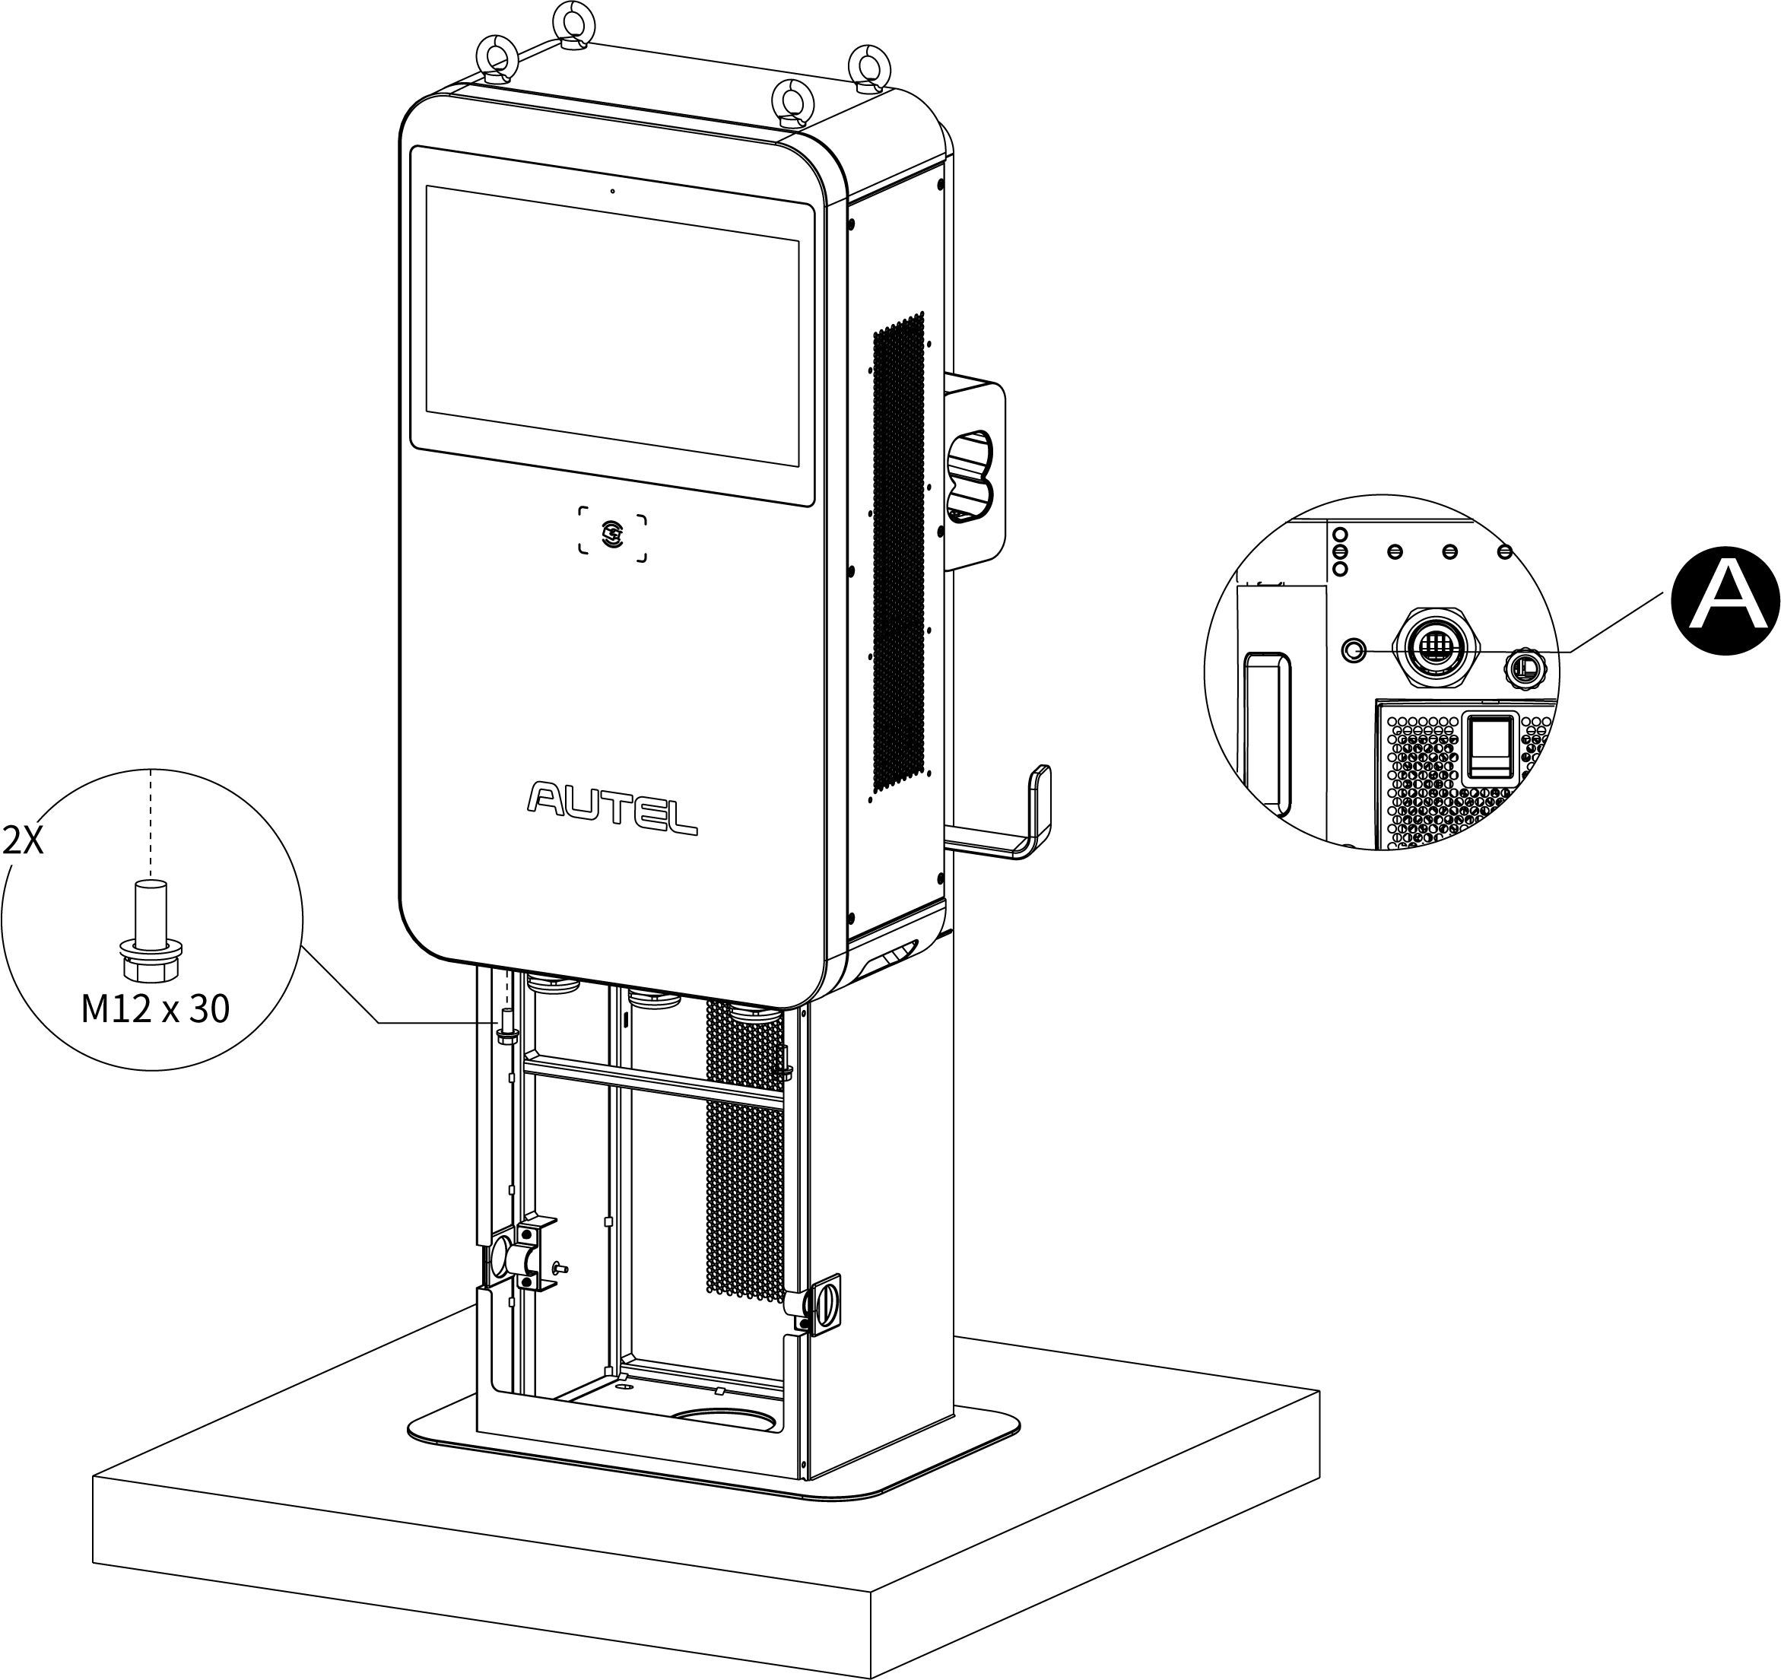

1. Remove the four lifting eyebolts and reinstall the top screws.

***Step 5: Organizing the charging cable***

1. Remove the two strain reliefs (**A**) by unscrewing the four M4 nuts on both sides of the pedestal using the Phillips screwdriver.

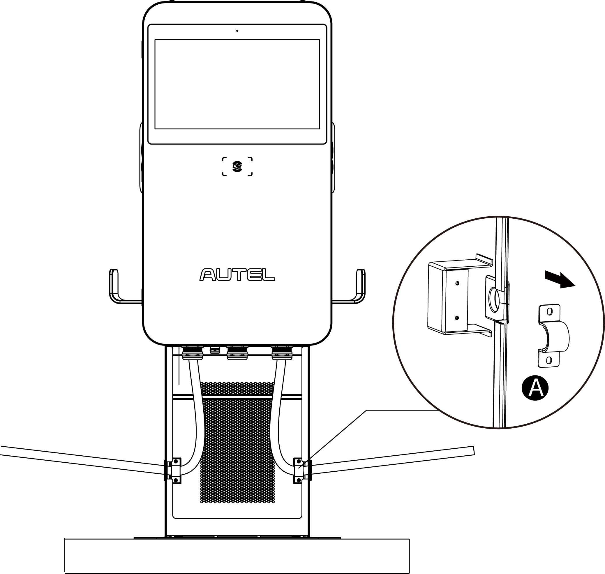

1. Put the cables into the rubber rings via the opening.
2. Reinstall the strain reliefs by screwing the four M4 nuts and tightening them to 1.2 N•m. Ensure the charging cables are allowed to remain its bending tolerance.
3. Drape the cables over the cable holders on both sides of the pedestal and plug the connectors into the holsters.

#### Integrated Type

***Step 1: Preparing a conduit***

1. Trench and excavate a cable tunnel to accommodate the conduit.
2. The conduit stub-up should be minimum 100 mm.
3. Pull the conduit and wire up through the exit opening, leaving 600 mm flexible length for the remaining installation activities.



***Step 2: Drilling holes***

1. Place the drilling template on the concrete surface, aligning its central hole with the exit opening.

**NOTE**

The side with a “Front” sign on the drilling template must be placed in the front.

1. Mark four holes on the concrete surface using a marker. Remove the drilling template.
2. Drill the four holes at the marked positions measuring 16 mm in diameter and 80 mm in depth.
3. Clean the dust ashes.



***Step 3: Removing the front cover***

Loosen the four M5 x 12 screws using the T25 Torx screwdriver to remove the front cover from the pedestal. Set them aside.

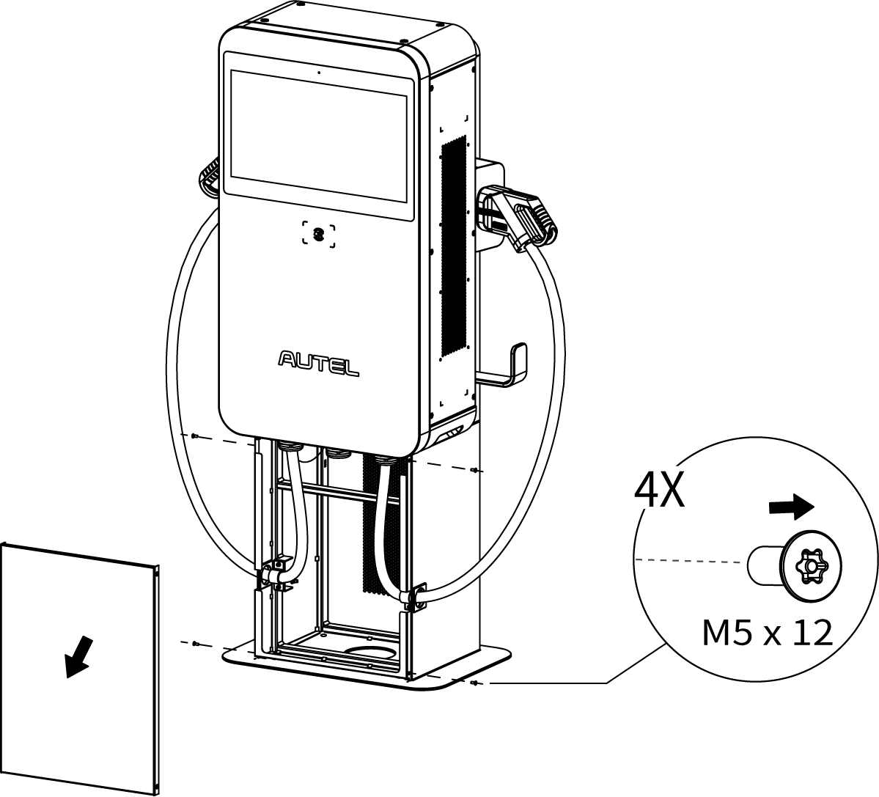

***Step 4: Mounting the MaxiCharger with pedestal***

1. Tap the four M12 x 80 expansion bolts into the four drilled holes. Remove the threaded bolts (**B**), spring washers (**C**), and flat washers (**D**) when the expansion sleeves (**A**) are stuck. Set them aside.



1. Lift the MaxiCharger with pedestal onto the mounting location by the hoisting equipment.
2. Reinsert the flat washers, spring washers, and threaded bolts in order and tighten them using a 19 mm socket wrench to 45–55 N•m.
3. Remove the four lifting eyebolts and reinstall the top screws.

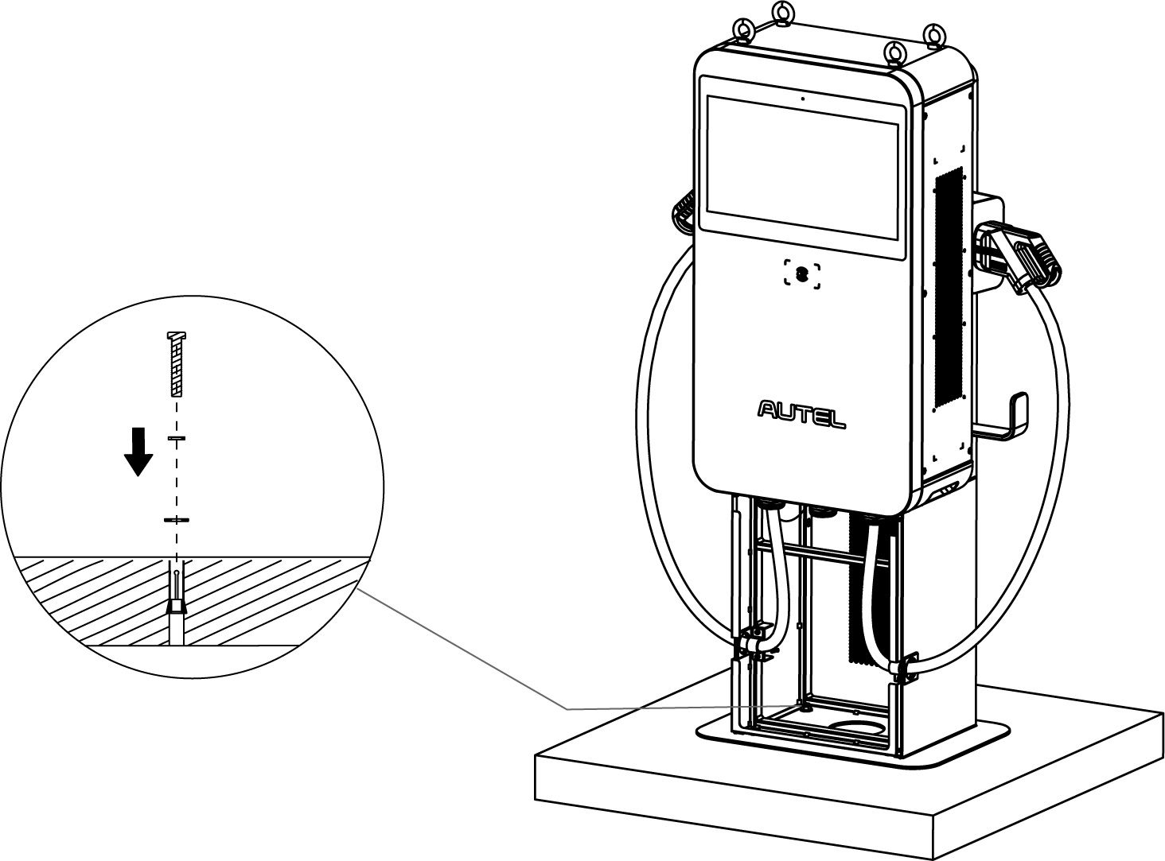

### Mounting on a Trolley

**IMPORTANT**

Always check local codes to ensure compliance. The guidelines described here are the minimum requirements. Ensure that the installation complied with all applicable codes.

The MaxiCharger with trolley can be delivered in individual or integrated type. The integrated type has been installed soundly. Just supply power to the MaxiCharger through the industrial plug, the MaxiCharger is ready to test.

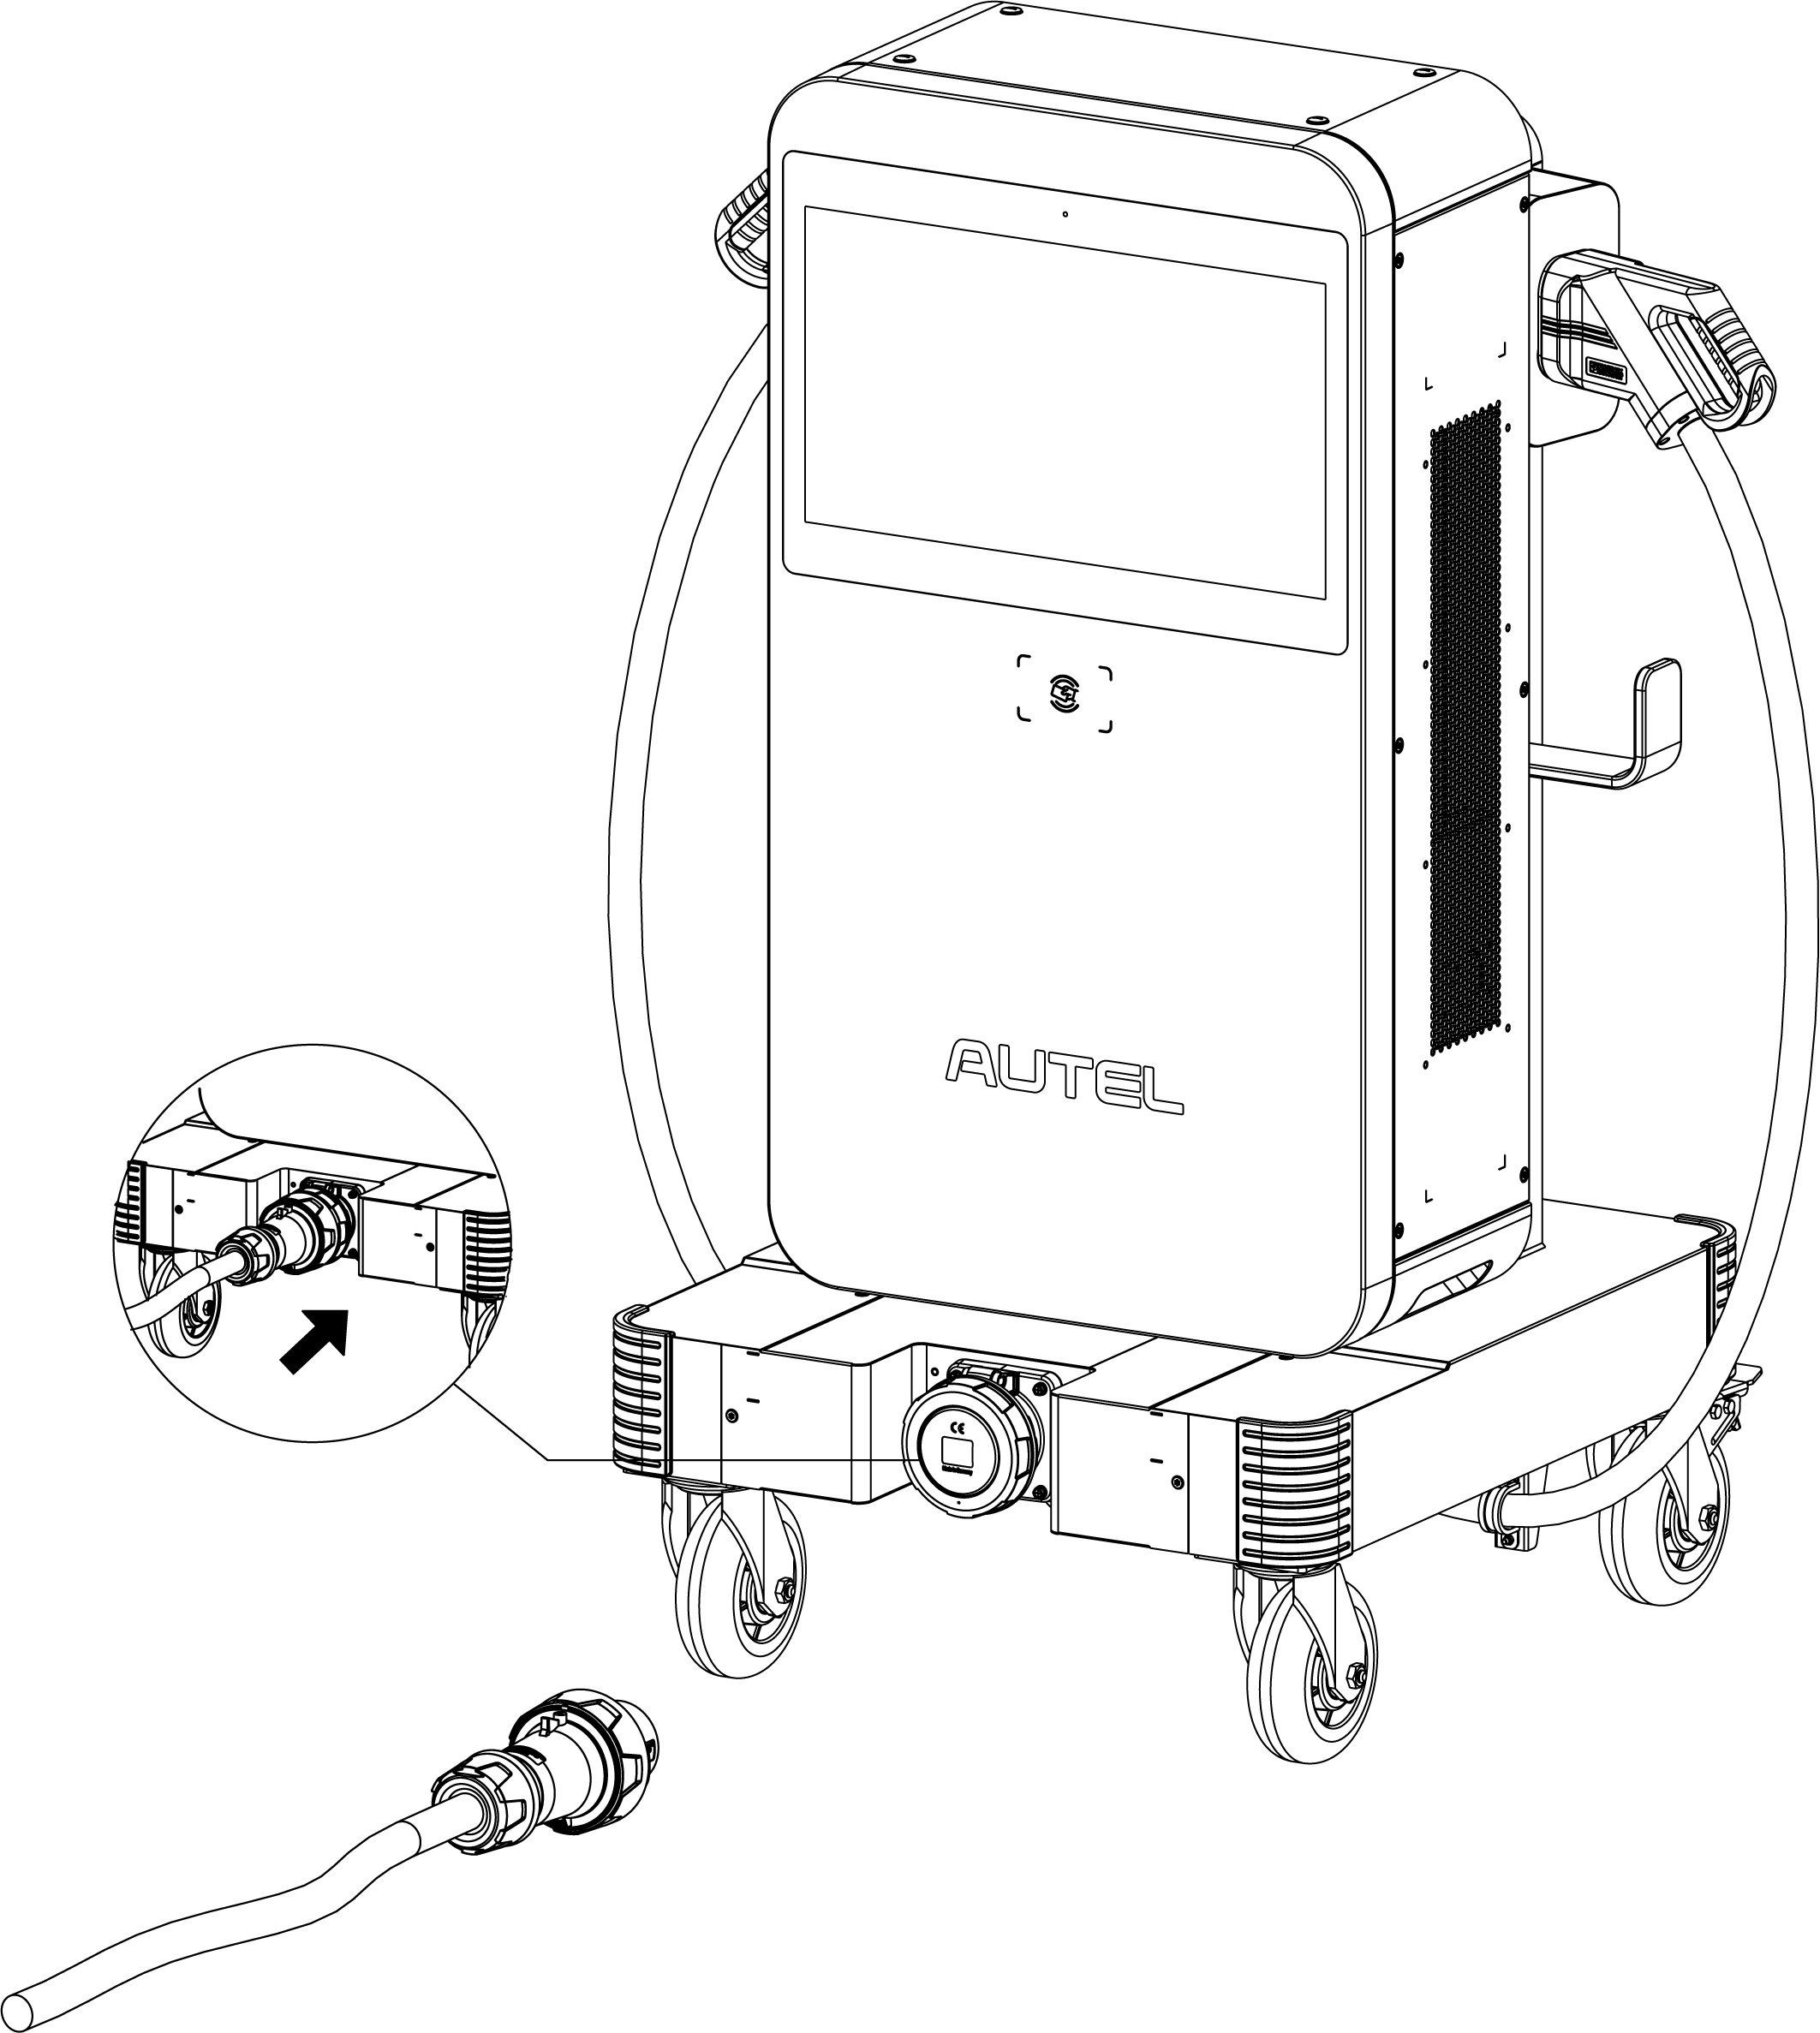

#### Individual Type

1. Use the T25 Torx screwdriver to loosen the four M5 x 12 screws to remove the front cover of the trolley. Set them aside.

**NOTE**

The AC input cable has been connected to the front cover of the trolley. Route the cable into the MaxiCharger from the bottom AC inlet hole after the MaxiCharger is securely attached.

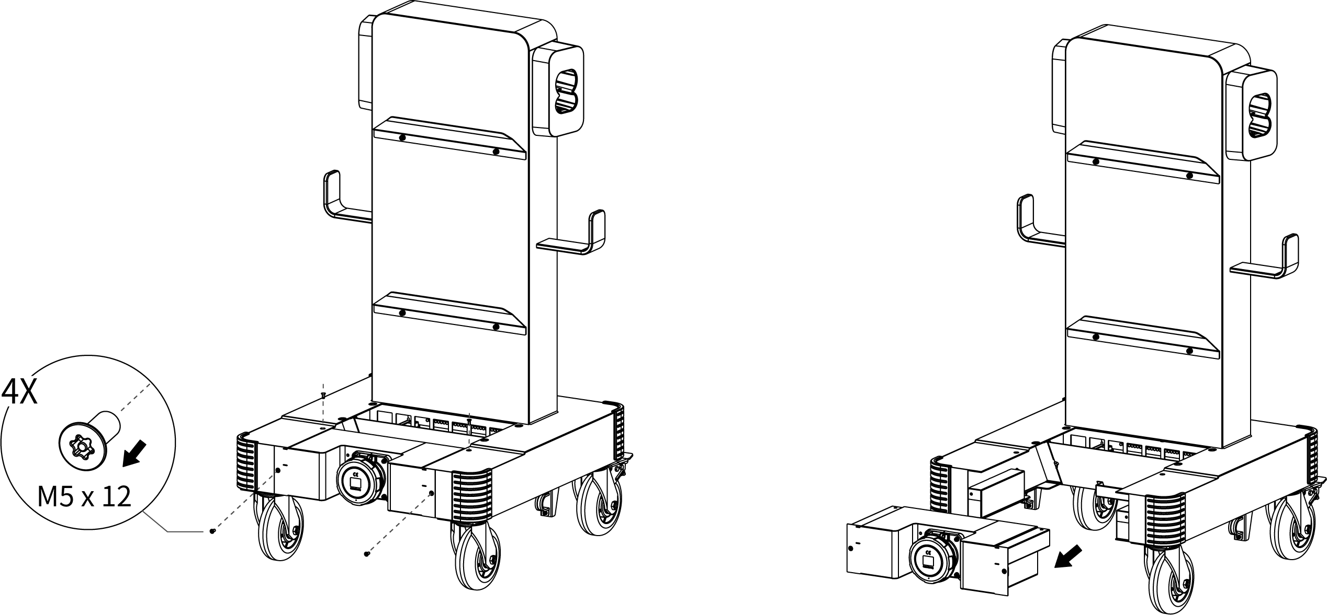

1. Lift the MaxiCharger onto the trolley. Position the groove (**B**) on the back of the MaxiCharger to fit the protrusion (**A**) of the trolley as shown below. Ensure the MaxiCharger is securely attached.

**NOTE**

When lifting the MaxiCharger onto the trolley, press the footbrakes on the two rear wheels to prevent moving.

1. Insert and fasten the two M12 x 30 screws using a 19 mm socket wrench to secure the MaxiCharger.

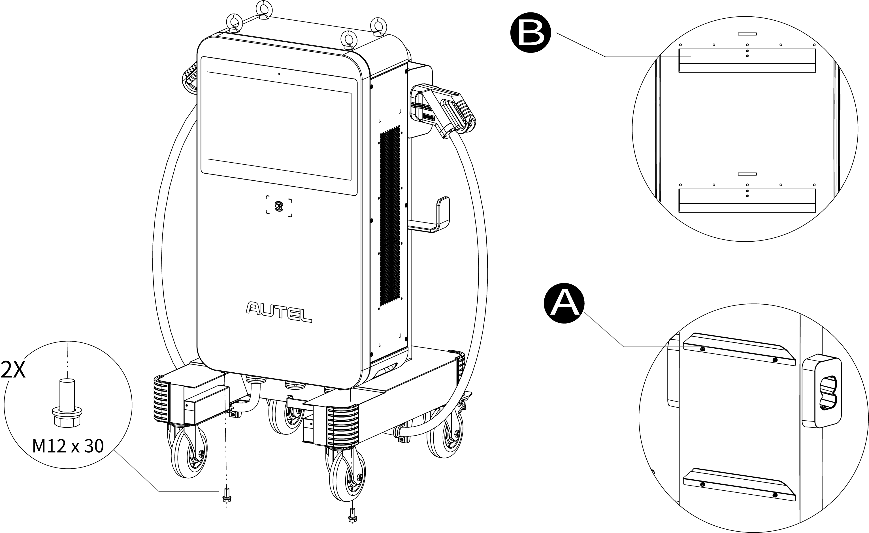

1. Use the two strain reliefs (**A**) (two M4 nuts for each) to secure the charging cables.

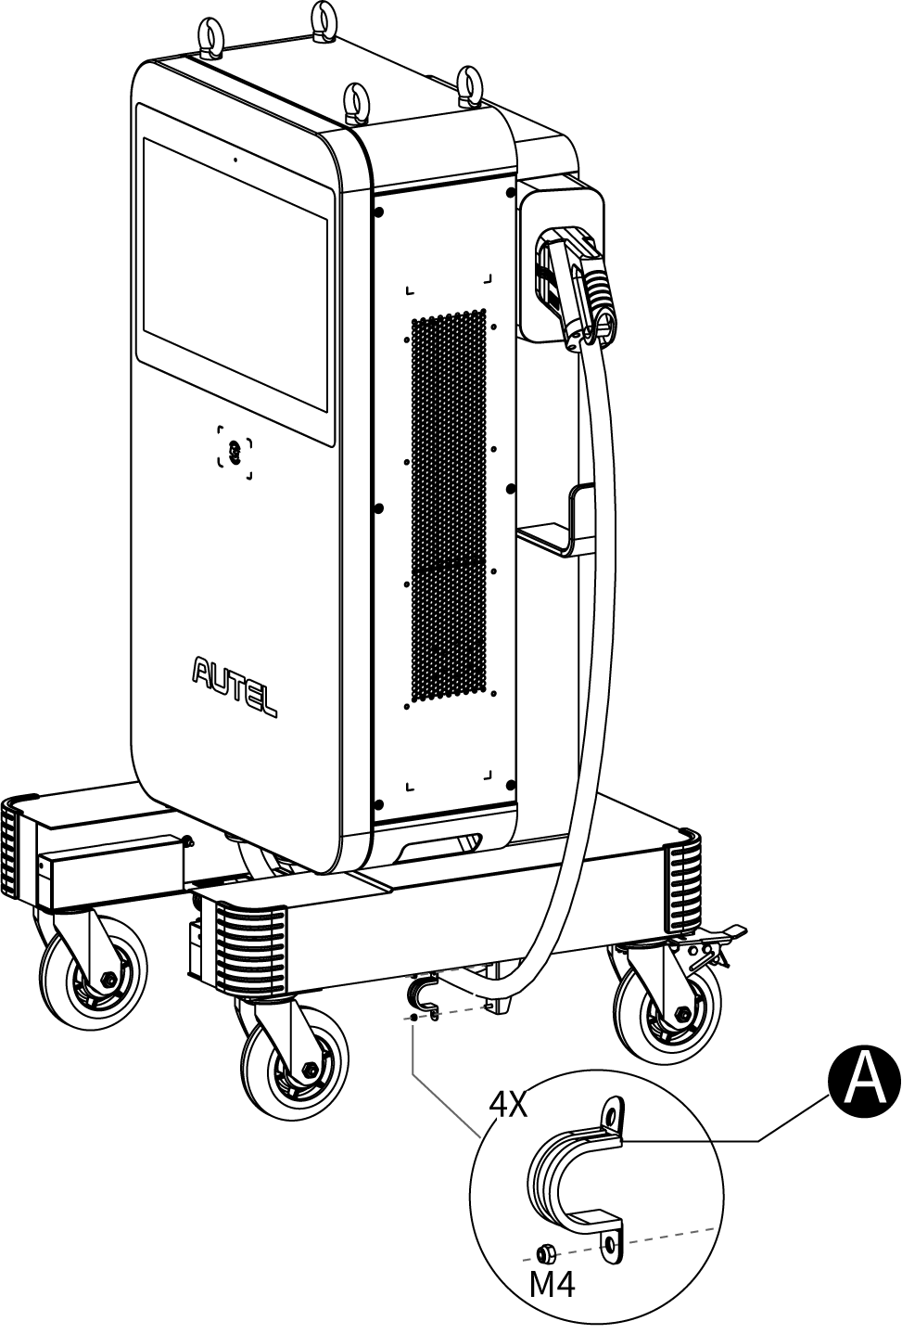

1. Remove the four lifting eyebolts and reinstall the top screws.

## Power Supply Wiring

**WARNING**

**Risk of Electric Shock**

* Only a qualified electrician should determine the electrical requirements and connect wires.
* Ensure the power is off before connecting the wires.

**IMPORTANT**

Before connecting wires, ensure the following requirements are met:

* Use 75 °C copper wire only.
* The circuit breaker at the panel must be off.
* The MaxiCharger must be grounded to true earth.
* An insulated grounding conductor must be installed as part of the branch circuit that supplies the MaxiCharger.
* The grounding conductor should be grounded to earth at the service equipment or, when supplied by a separately derived system, at the supply transformer.
* All connections must comply with all local codes and ordinances.
* Use 25 mm2 wires.

**NOTE**

The MaxiCharger with trolley (integrated type) can skip this Chapter **4.4**.

### Opening the Door

1. Remove the six M5 x 20 screws on the right side of the MaxiCharger using the T25 Torx screwdriver to remove the side cover (**A**). Set them aside.

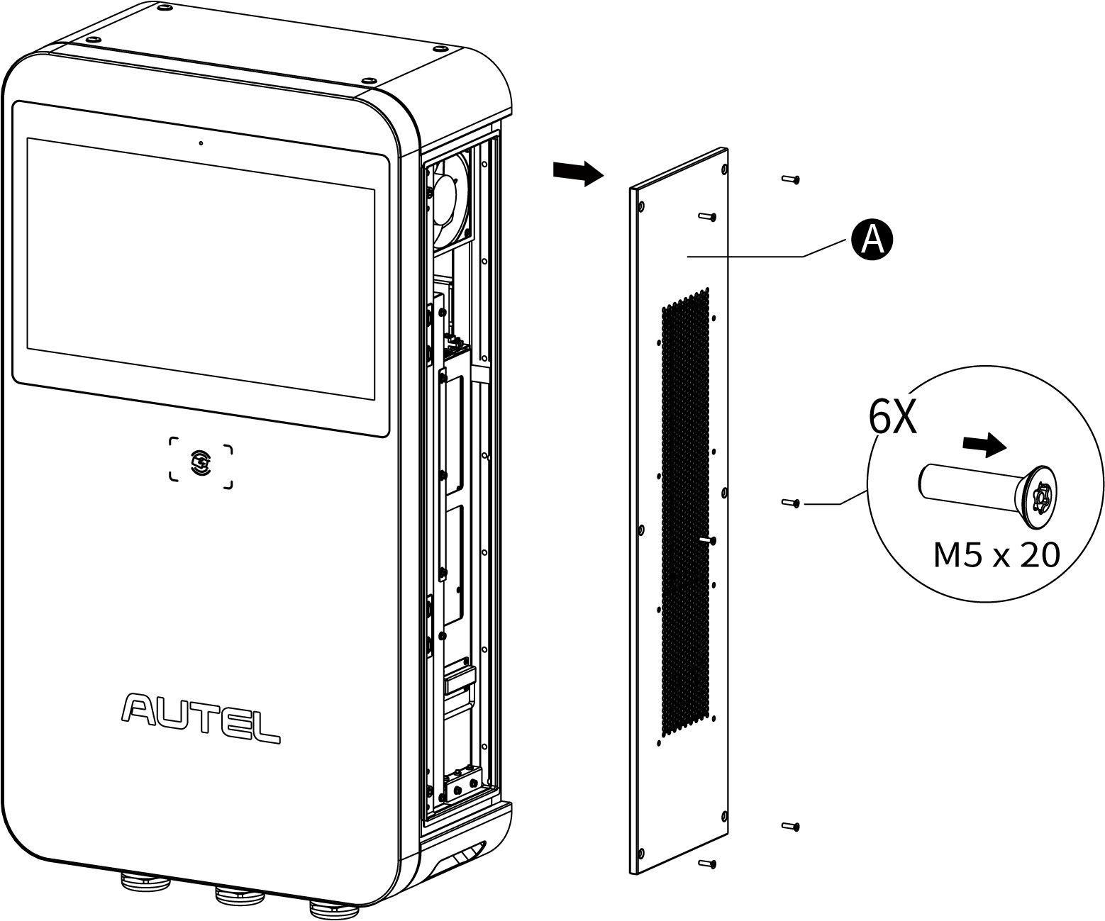

1. Loosen the two M8 hex screws (**A**) using the hex key and open the front door.

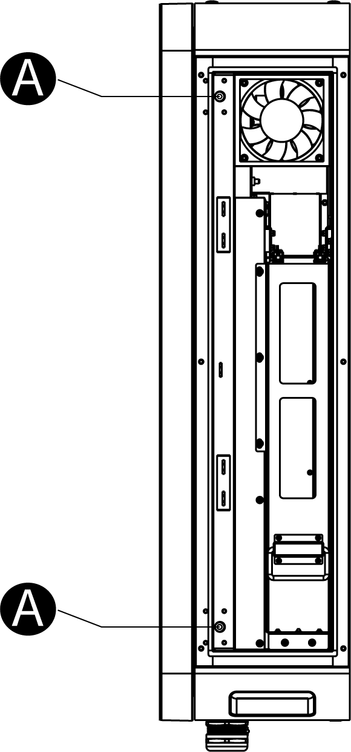

### Connecting the AC Input Cable

1. Loosen the three M6 nuts to remove the insulating barrier (**A**) and set them aside.

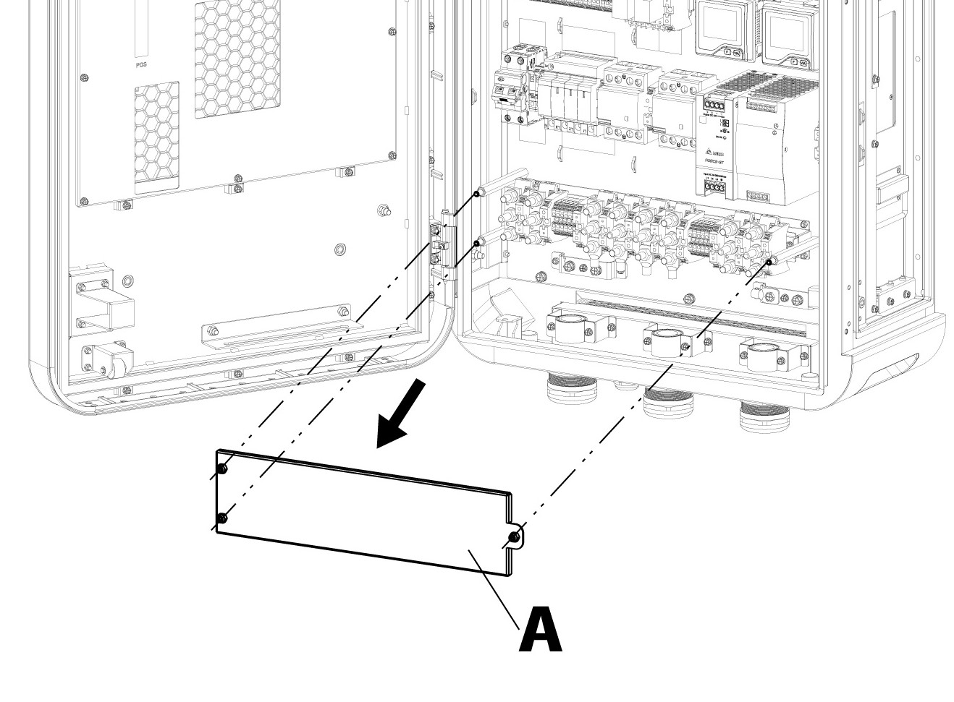

1. Pull the wires and guide them through the bottom AC inlet hole.
2. Use a wire stripper to remove an appropriate length of the insulation from the end of individual wires. Ensure the stripped length is compatible with cable lugs.
3. Use the crimping tool to attach the cable lug to the end of the wires.

**NOTE**

The MaxiCharger with trolley (individual type) can skip the Step **3** and **4**.

1. Loosen the M6 fastener using a 10 mm socket wrench and connect the PE wire to the PE busbar (**A**). Reinsert the fastener and tighten it to 6 N•m.
2. Use a 13 mm wrench to loosen the four M8 fasteners and attach the wires to the connectors:

* L1 wire to the connector **B**
* L2 wire to the connector **C**
* L3 wire to the connector **D**
* N wire to the connector **E**

1. Reinsert the M8 fasteners and tighten them to the torque 6–12 N•m.

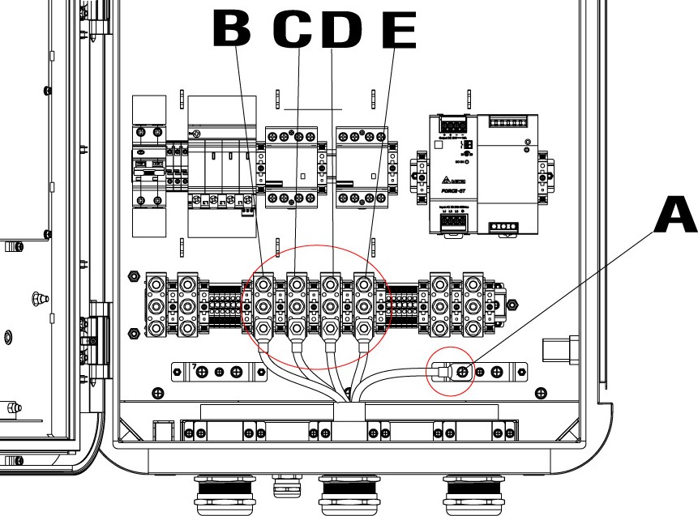

### Powering on the MaxiCharger

**Before Power-on**

* Install the MaxiCharger according to the instructions in this manual.
* Prepare an emergency plan to instruct people what to do in case of an emergency.
* Only the manufacturer or a qualified technician authorized by the manufacturer can commission the MaxiCharger. Contact the manufacturer when the MaxiCharger is ready for commissioning.

**NOTE**

In the event of ambient temperature lower than -20 °C, it will take 3~5 minutes to preheat the screen when powering on the MaxiCharger. In extreme cases, the display module will be reset to ensure the stability of the MaxiCharger.

* To power on the MaxiCharger

1. Make sure that the upstream breaker stays in the **OFF** position and locked during the procedure.
2. Tighten the screws and bolts of key parts and make sure the cabinet is clean inside. Prevent the electronic components from being damaged by dust or particles.
3. Use the multimeter to check the circuit connections among L1, L2, L3, N, and PE. If short circuit occurs, contact Autel technical support; otherwise, reinstall the insulating barrier.
4. Contact Customer Technical Support to turn on the upstream breaker and check the indicators on CCU, ECU and TCU and the screen display.

* If any indicator of CCU, ECU, or TCU is off or the screen display is abnormal, please contact Autel technical support;
* If all indicators and the screen display normal, go to next step.

## Connecting the Ethernet Cable

**NOTE**

The MaxiCharger with trolley prefers to access the Internet via cellular data or Wi-Fi for movability.

1. Loosen the cable gland (**A**).
2. Put the Ethernet cable through the Ethernet cable port at the bottom of the MaxiCharger.
3. Plug the Ethernet cable into the RJ45 port.
4. Tighten the cable gland (**A**).

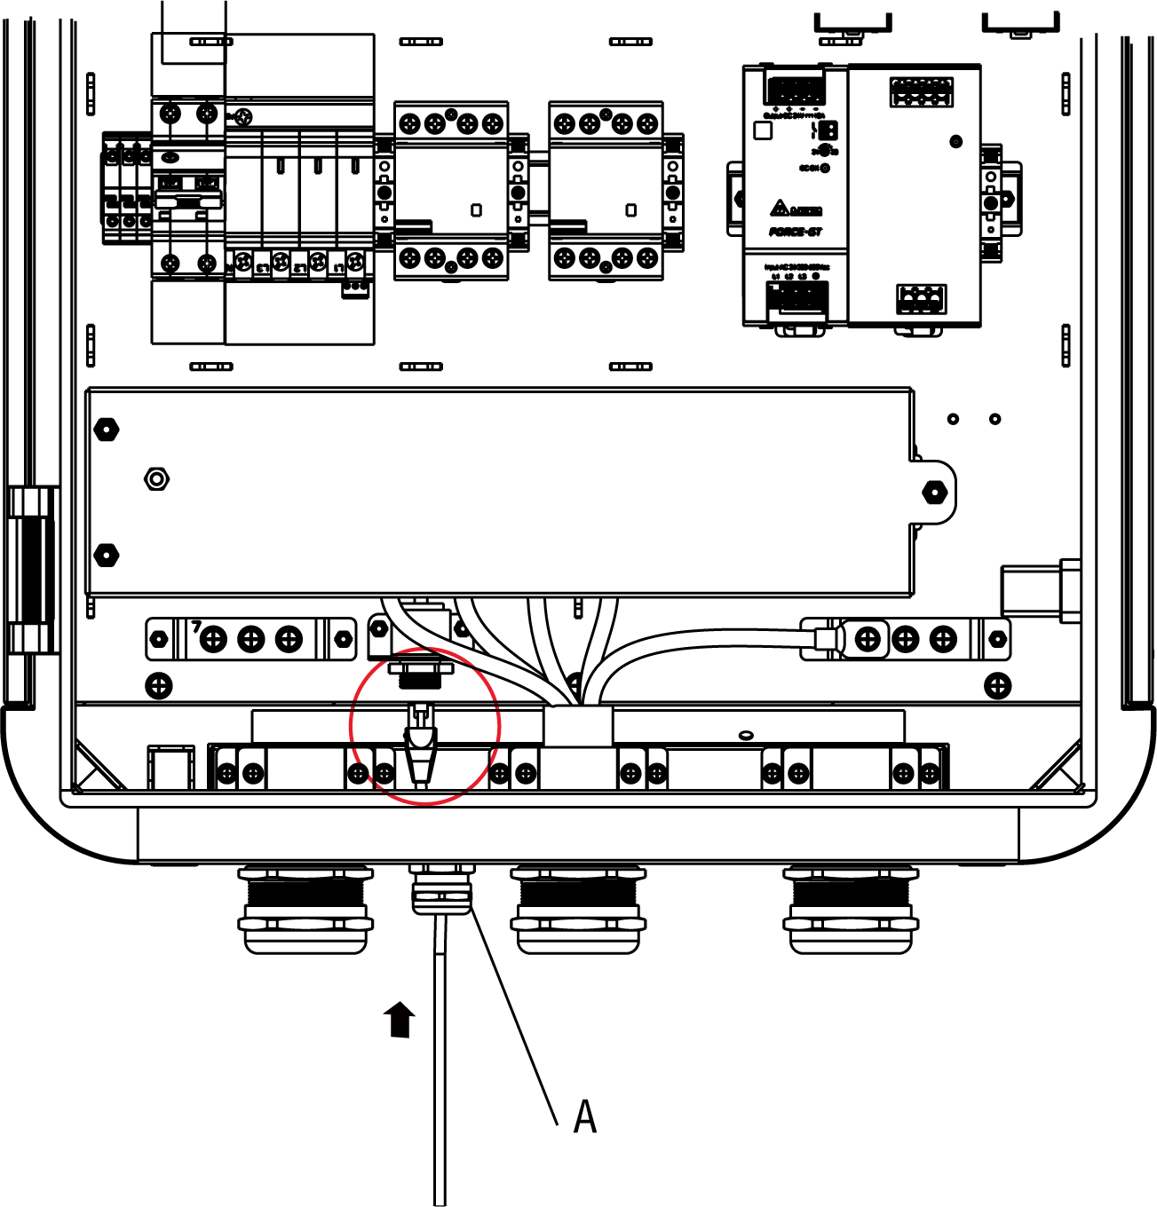

## Installing the SIM Card

1. Press the button (**A**) to release the SIM card tray.
2. Insert a SIM card into the tray. Ensure the card is placed correctly.
3. Push the SIM card into the slot.

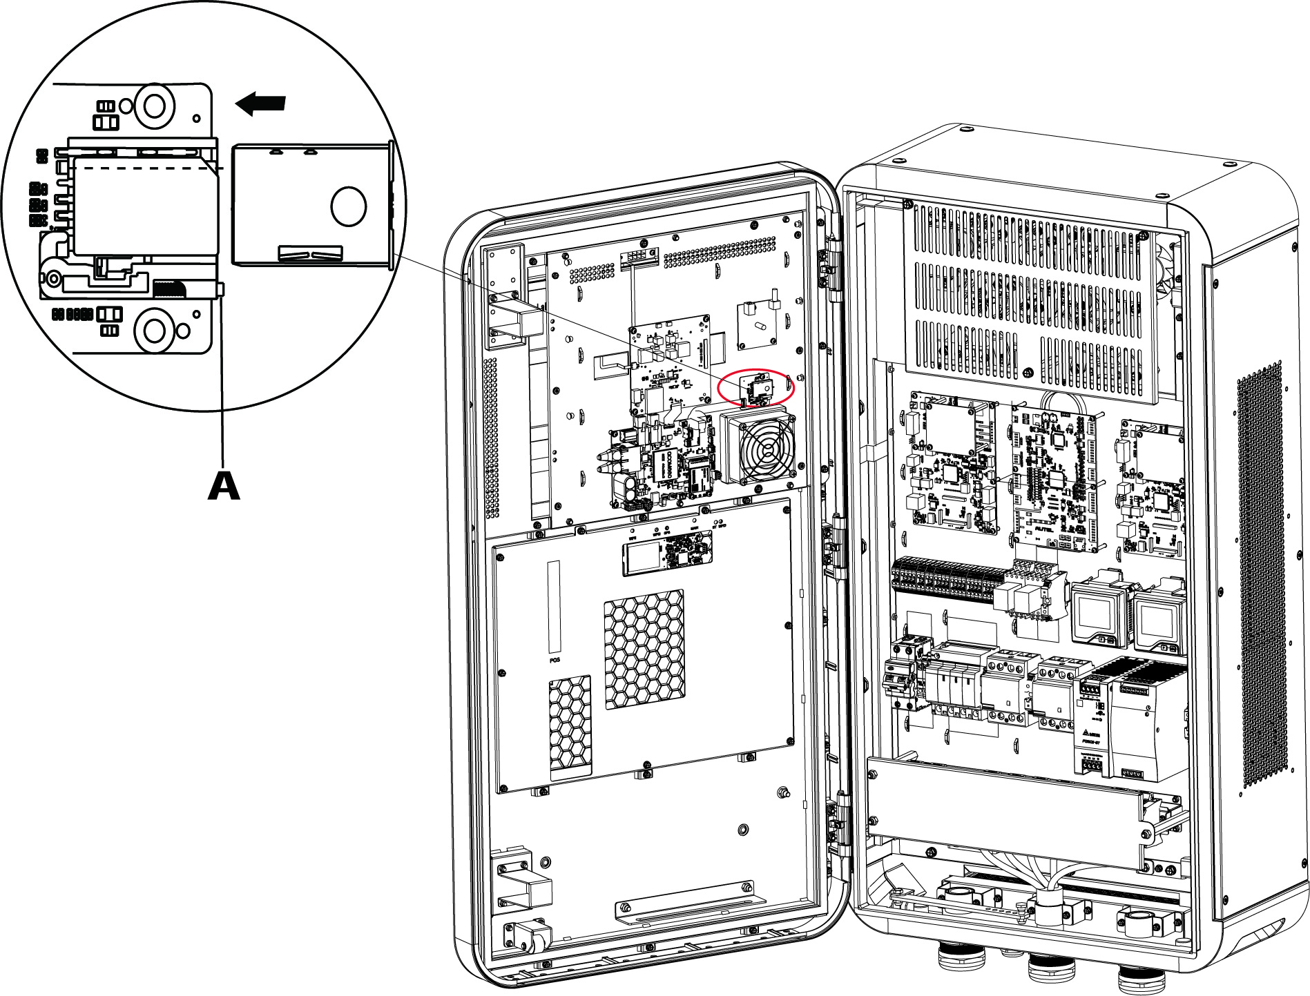

## Completing Installation

### For Mounting on a Wall:

1. Close the front door by reinstalling the two M8 hex screws using the hex key and fully tightening the screws.
2. Reinstall the side cover (**A**) by inserting and tightening the six M5 x 20 screws to 2 N•m using the T25 Torx screwdriver.

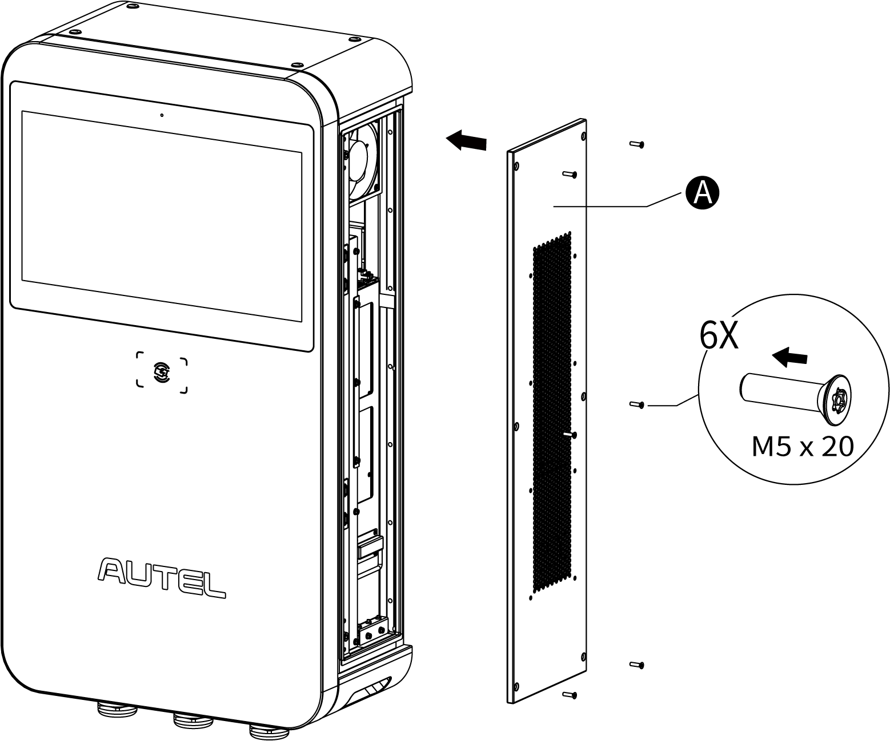

### For Mounting on a Pedestal:

1. Close the front door by reinstalling the two M8 hex screws using the hex key and fully tightening the screws.
2. Reinstall the side cover by inserting and tightening the six M5 x 20 screws to 2 N•m using the T25 Torx screwdriver.
3. Reinstall the pedestal’s front cover by screwing the four M5 x 12 screws and tighten them to 2 N•m.

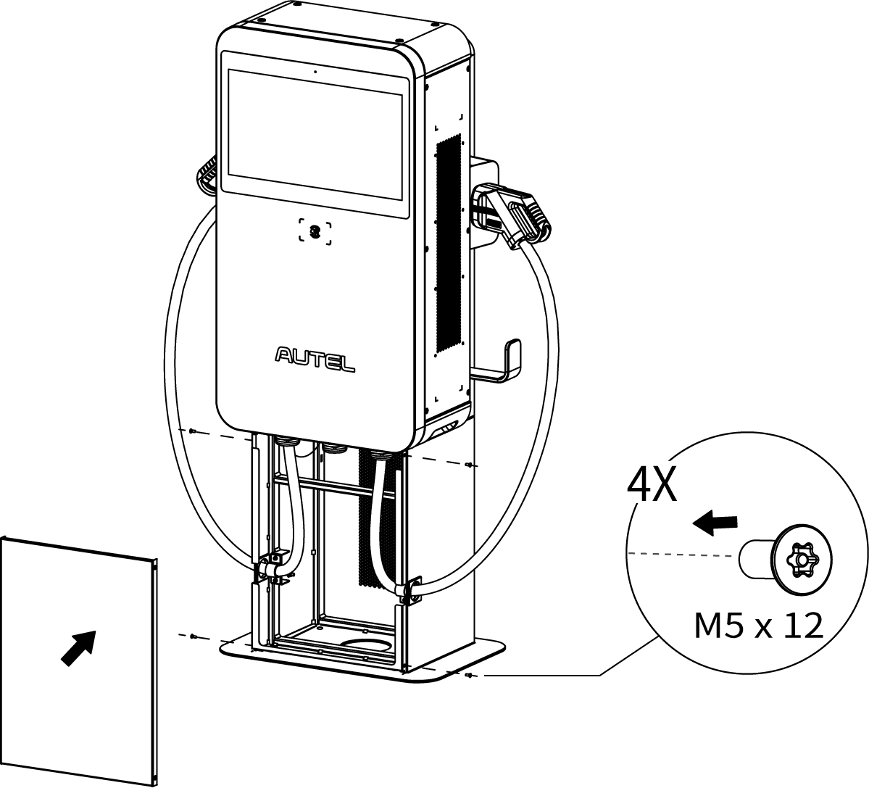

### For Mounting on a Trolley (Individual Type):

1. Close the front door by reinstalling the two M8 hex screws using the hex key and fully tightening the screws.
2. Reinstall the side cover by inserting and tightening the six M5 x 20 screws to 2 N•m using the T25 Torx screwdriver.
3. Reinstall the front cover of the trolley by inserting and tightening the four M5 x 12 screws.

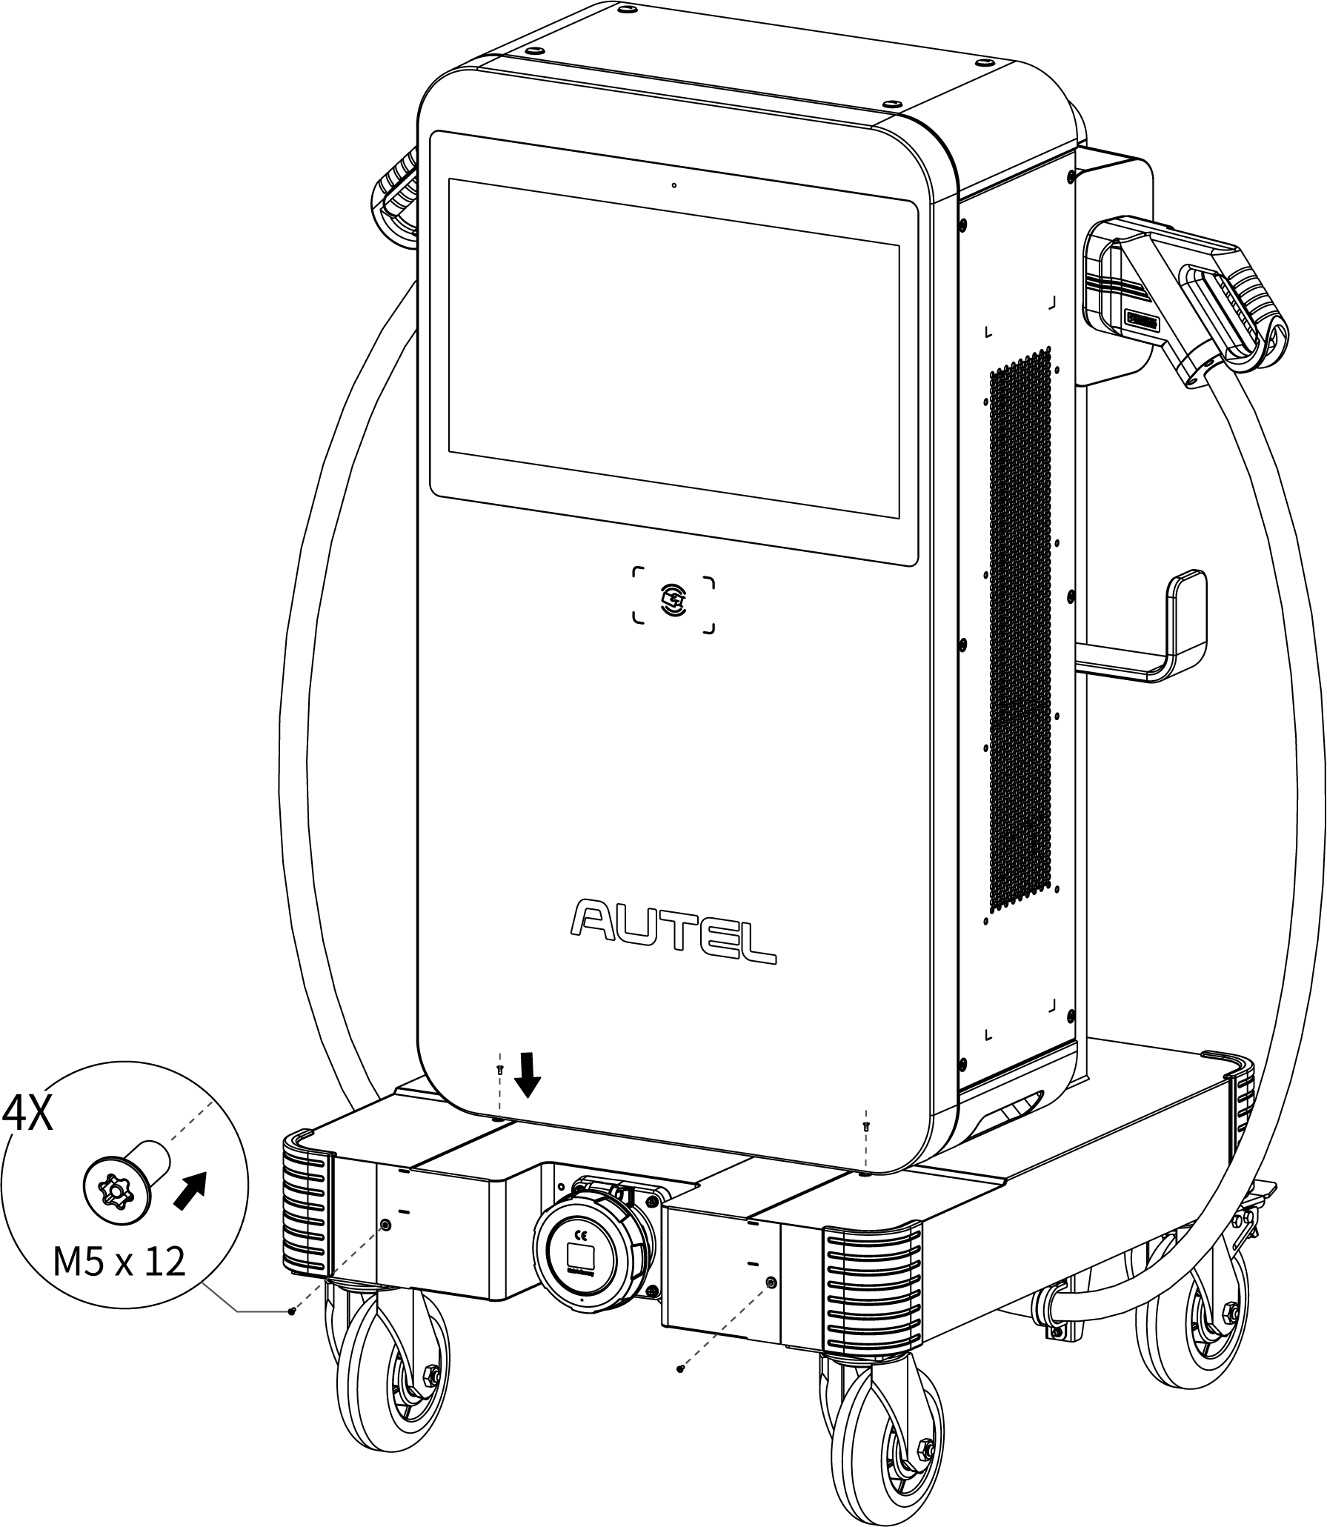

## Installing the Upstream Protective Device

|  |  |
| --- | --- |
| **Devices** | **Specifications** |
| Dedicated upstream protection device(s) | Options:   * RCD (Type A) + MCB * RCBO (Type A) |
| Upstream overcurrent protection breaker, such as RCBO or MCB  (The breaker serves as the main disconnect switch to the MaxiCharger.) | Breaker rating should not be less than 100 A.  Tripping characteristics: type C |
| Upstream residual-current device (RCD) | Type A, with a rated residual operation current of 30 mA |

## Preparing for Commissioning

**IMPORTANT**

Only a manufacturer qualified service engineer can commission the MaxiCharger.

* **To perform the commissioning**

1. Ensure the site complies the following requirements:

* The MaxiCharger is installed according to the instructions in this manual.
* AC input power is available.
* Internet access is available through a wired Ethernet connection, cellular service, or Wi-Fi.
* An EV of each type of connector must be available for a compatible test during commissioning.
* The site operator or owner is available to receive instructions from the manufacturer certified service engineer when the MaxiCharger is installed.

1. Ensure the following information is collected:

* Name and address of the site
* Contact information of the on-site contact person
* Specification of the external fuse or breaker at the power distribution panel
* Date when the installation is done
* Photo of the MaxiCharger and the site surroundings
* Special remarks (if any)

1. Someone should be present for assistance to energize the power to the MaxiCharger on the distribution panel.

**IMPORTANT**

The conduit opening must be sealed to protect the wiring from the environment.

# Operation

## Charging Procedure

General charging procedures:

* **To charge an EV**

1. Park an EV with the charging port within reach of the connector.
2. Plug in the EV.
3. Start the charging session.
4. ****Stop the charging session.

**WARNING**

* Do not cover the vent during charging.
* Do not clean or operate in the EV during charging.

### Standby Mode

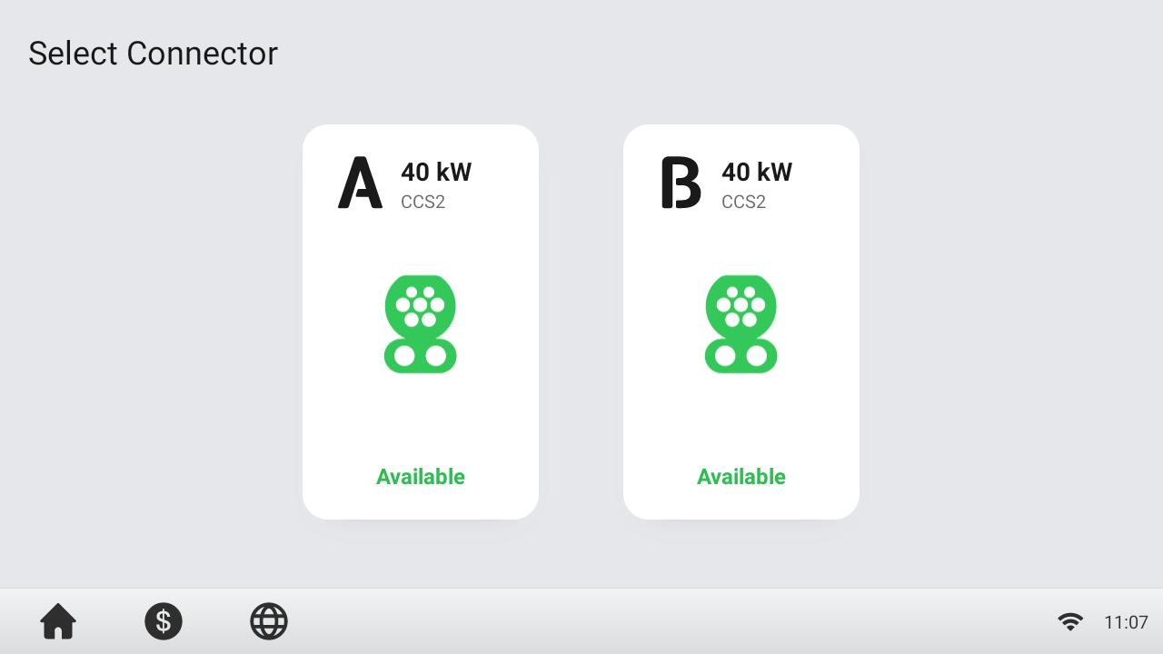

After a connector is successfully connected to your EV, the MaxiCharger can automatically recognize the connector, then the corresponding connector’s Authorization Screen will appear.

If no operation is performed for a long time on the Authorization Screen, the Standby Screen will appear. Manually select the appropriate connector on the touchscreen.

### Authorization

**IMPORTANT**

* Observe the screen for any abnormalities, such as an error messages, before starting a charge session. Check the surroundings and the MaxiCharger for any abnormalities or damage as well.
* If the screen displays an error message, DO NOT use the MaxiCharger. Contact Autel Technical Support.

When the Authorization Screen appears, you can use any of the following methods to start a charge session.

* Scan the QR code on the screen
* RFID card
* Plug & charge (supports the ISO 15118 PnC function)
* Credit card (optional)

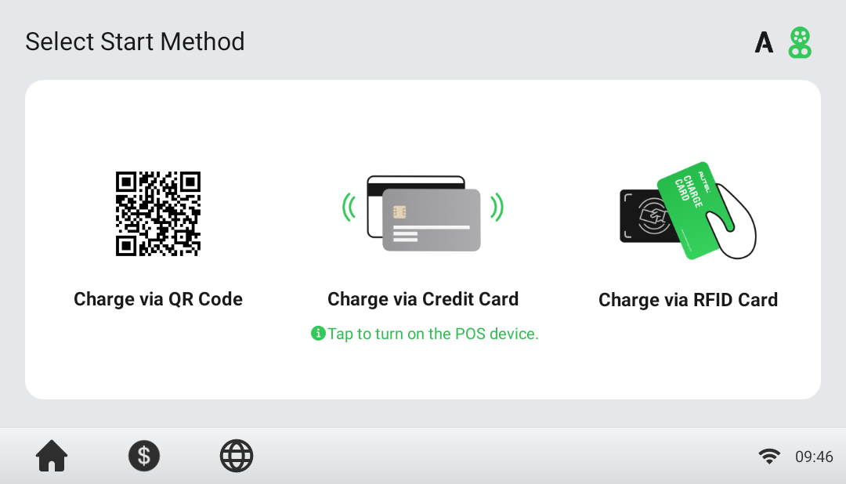

### Start Charging

After authorization, the MaxiCharger will set up communication with your EV and necessary safety tests will be performed. Following the safety tests, the charge session will start automatically.

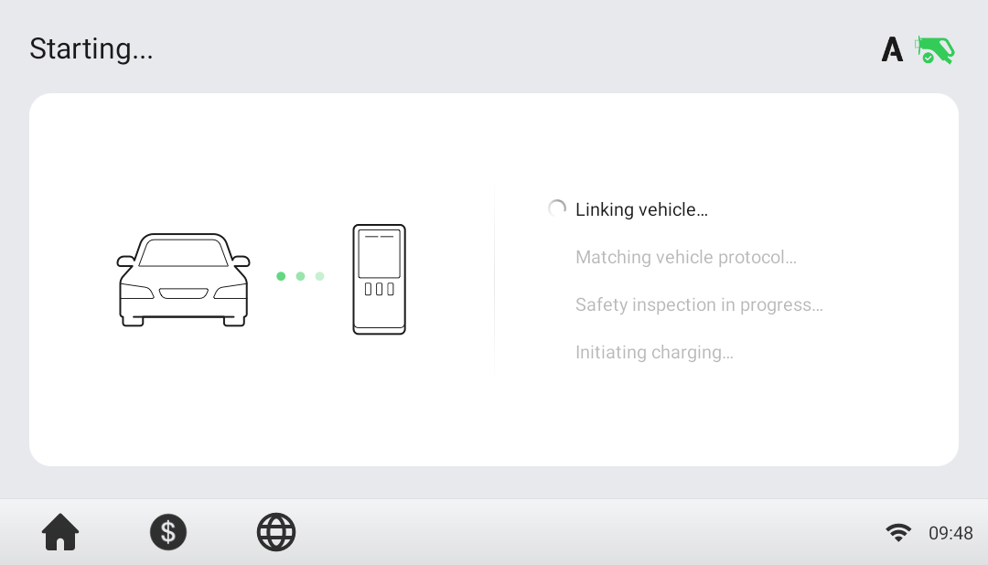

### Charging

You will be informed of the progress during charging. Information about the charging duration, energy, cost, and power will appear on the Charging Screen. Tap the **Right Arrow** button on the right to view more information about the charging status.

Wait until your EV is fully charged or terminate the charge session by tapping the **Stop** button on the screen.

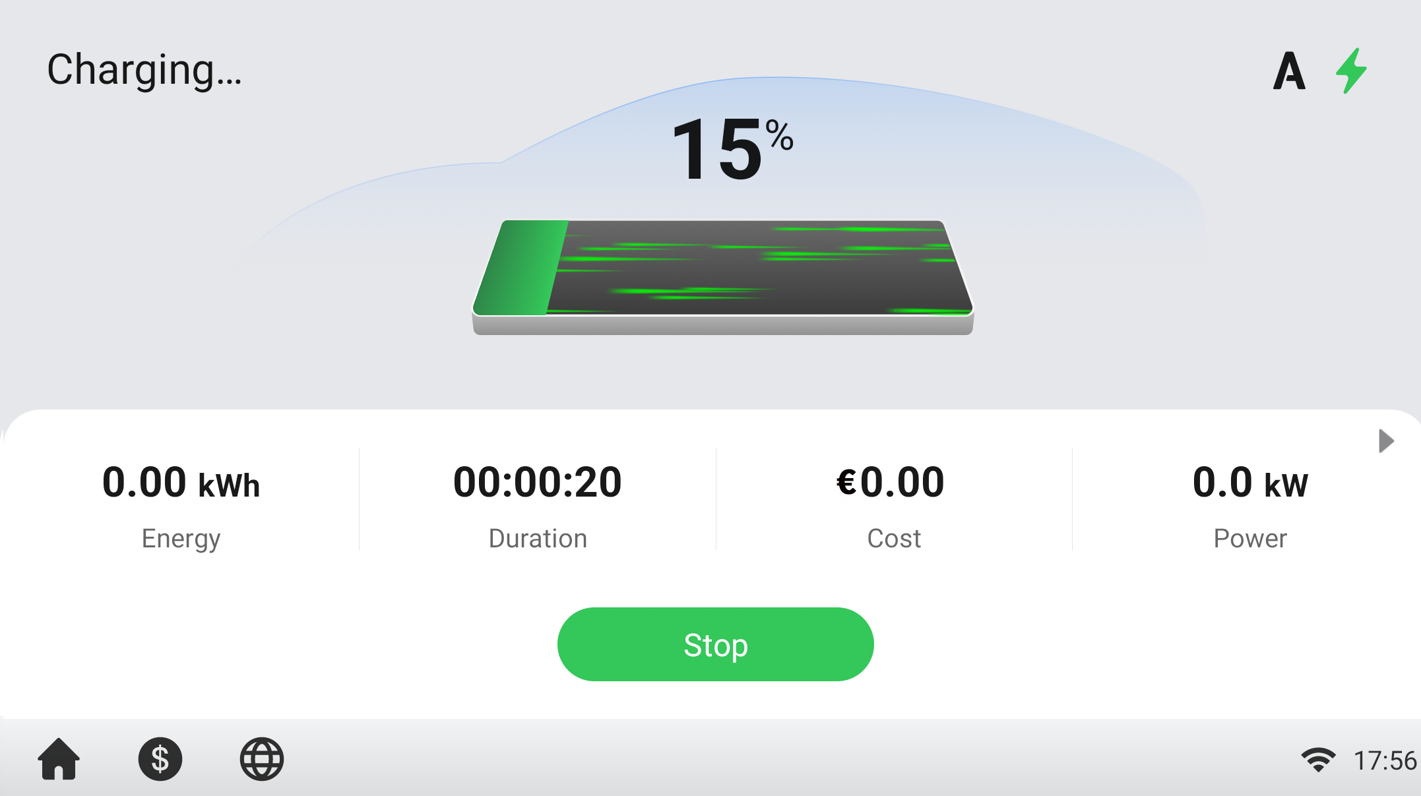

### Stop Charging

* To stop charging

1. Tap the **Stop** button on the screen.

**NOTE**

When the battery is full, the charge session stops automatically.

1. Normally, you have to authorize again to finish charging, using the same authentication method as was used to start:

* QR code: Scan the QR code by the Autel Charge app and tap the **Stop** button on the Charging Screen of the Autel Charge app.
* RFID card: Put the RFID card on the card reader again to finish charging.
* Credit card: Finish charging directly.

1. When charging is finished, your transaction details will appear.

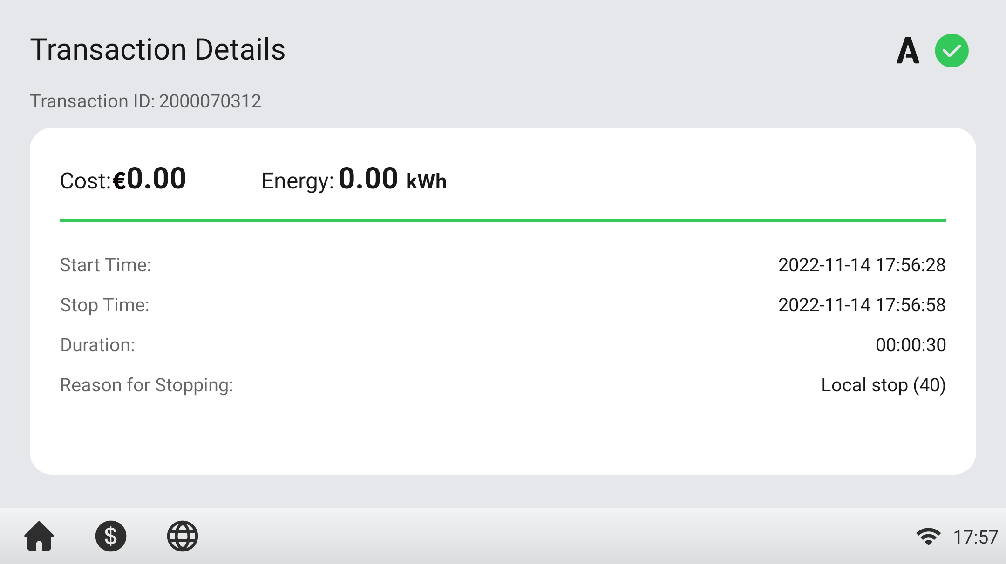

1. Disconnect the EV charging cable from the EV.

**WARNING**

Hazardous voltage. Do not unplug the connector suddenly during charging. This may cause severe damage to the MaxiCharger and/or severe personal injury or death.

### Finish Charging

Return the connector to the holster on the MaxiCharger.

## Charging Errors

This section depicts several common problems that may arise during your charging session, along with possible causes/solutions to help you resolve those problems. If the problem persists, contact your local dealer or Autel Technical Support.

### Connector Connection Error

If the connector is not properly connected to your EV, then the Connector Not Connected screen will appear. Insert the connector into your EV’s charge port and check the connection.

### Authorization Failure

If an error occurs when you start the authorization process but without starting charging, the Authorization Failure screen will appear. The cause and possible solution(s) will display on the screen. Follow the on-screen instructions to resolve the problem, or contact your local dealer or Autel technical support.

### Charging Start Failure

If an error occurs when you start charging, the Charge Start Failure screen will appear. The cause and possible solution(s) will display on the screen. Follow the on-screen instructions to resolve the problem.

### Charging Failure

If an error occurs during charging, the Charging Failure screen will appear. The cause and possible solution(s) will display on the screen. Follow the on-screen instructions to resolve the problem, or contact your local dealer or Autel Technical Support.

## Powering down the MaxiCharger

* To power down the MaxiCharger

1. Set the upstream breaker which provides the power to the MaxiCharger to **OFF** and lock it. Make sure that this breaker stays in the **OFF** position during the procedure.
2. Open the front door.
3. Measure the AC voltage by referring to *Measuring the AC Voltage*. Make sure that all the measured voltages are 0 volts.
4. Measure the DC voltage by referring to Measuring the DC Voltage. Make sure that all the measured voltages are 0 volts.
5. Close the front door.

### Measuring the AC Voltage

Use a voltage tester to measure the AC voltage between the terminals on the surge protection device switch:

* L1 to L2
* L1 to L3
* L2 to L3
* N to L1/L2/L3

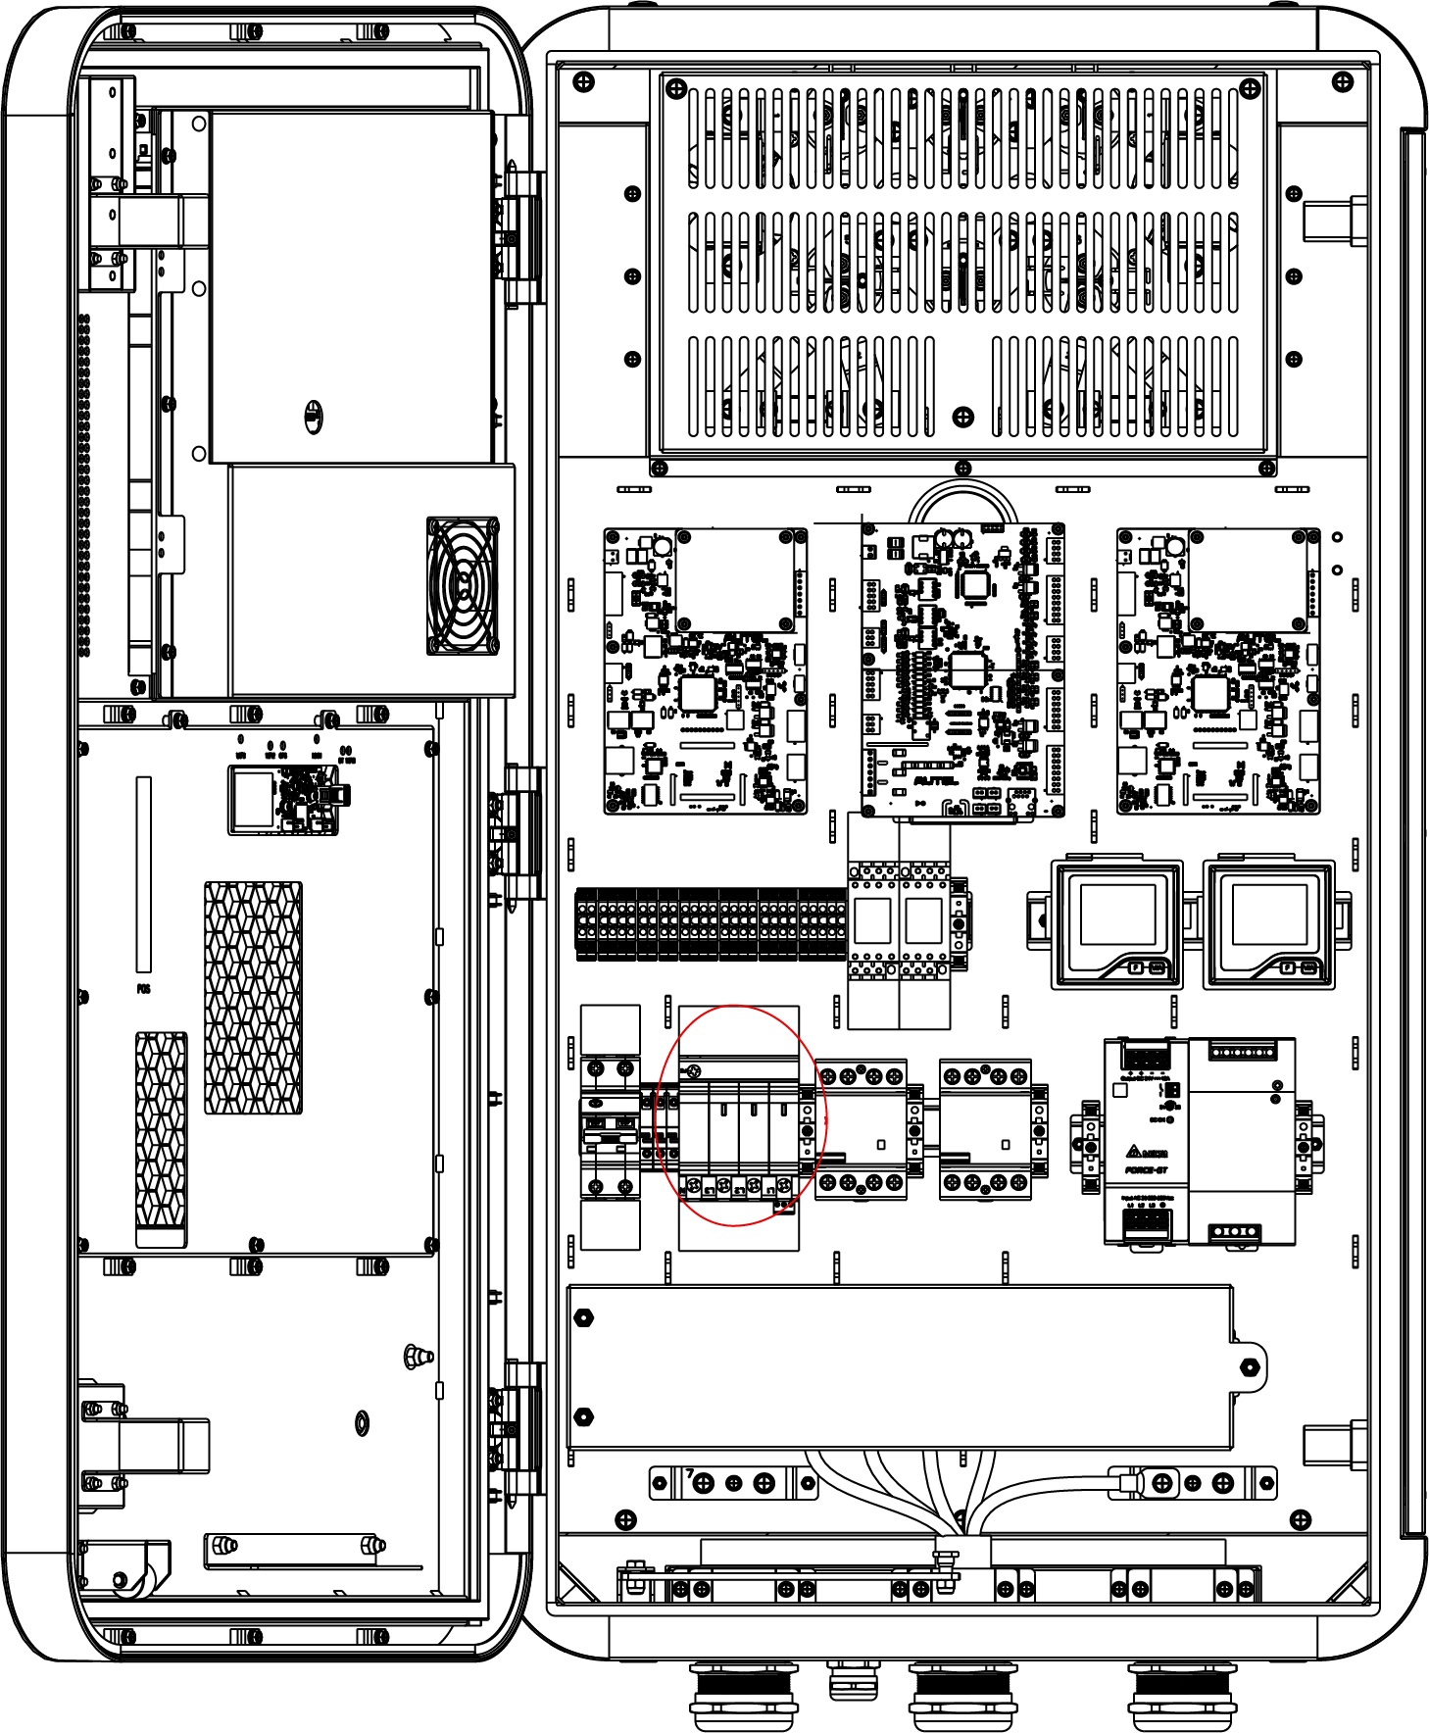

**NOTE**

The surge protection device switch shows the indica tions N, L1, L2, and L3.

### Measuring the DC Voltage

Use a voltage tester to measure the DC voltage between the output terminals, make sure that all the measured voltages are 0 volts.

* Power module group output 1 — (**A**) to power module group output 1+ (**B**)
* Power module group output 2 — (**C**) to power module group output 2+ (**D**)
* EV charging cable 1 output — (**E**) to EV charging cable 1 output + (**F**)
* EV charging cable 2 output — (**G**) to EV charging cable 2 output + (**H**)

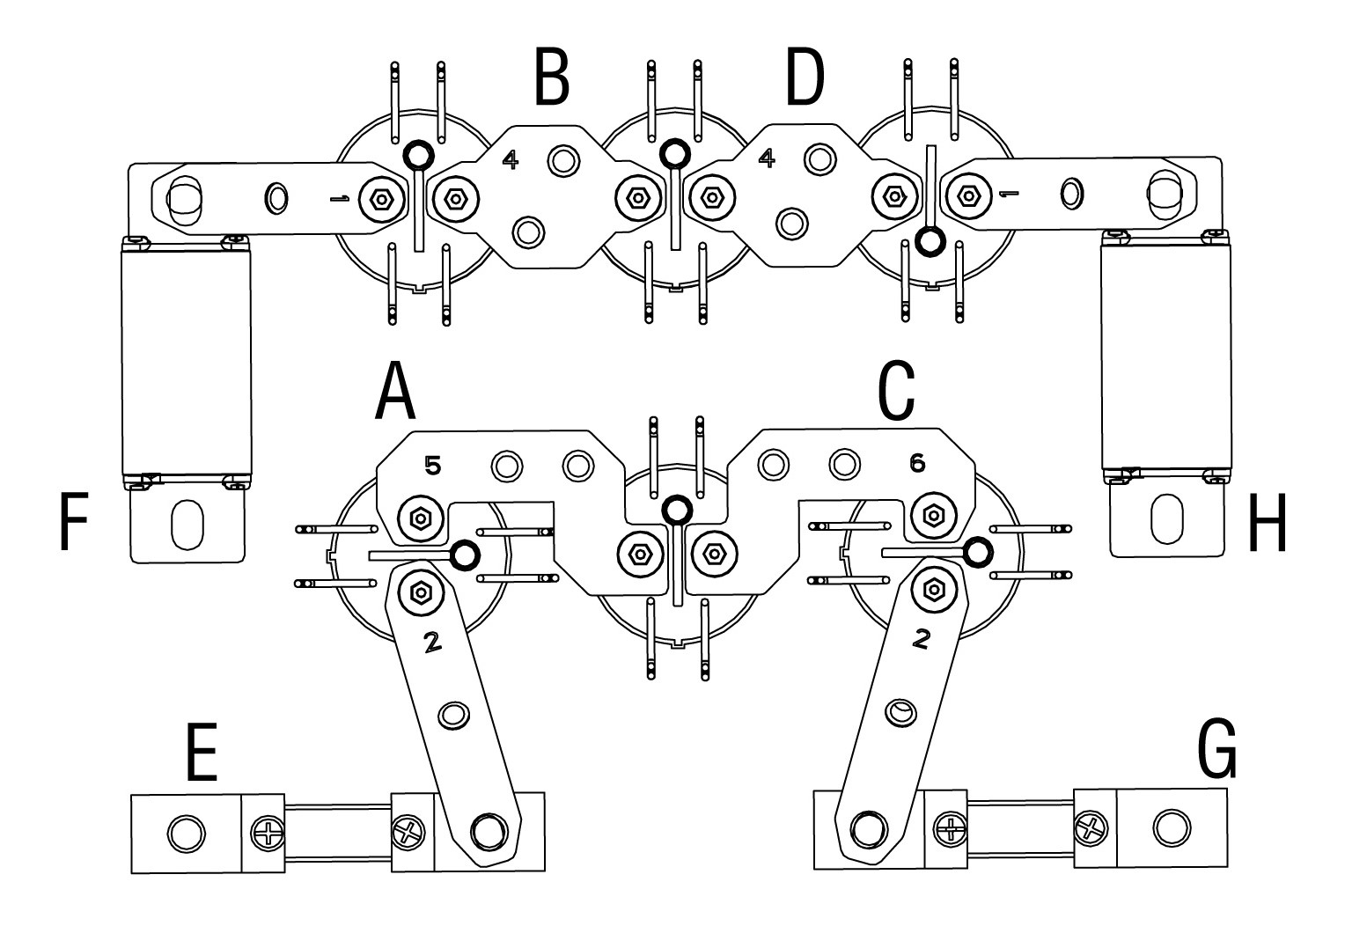

## Local Service Portal Operations

### Setting the OCPP Parameters

**NOTE**

The OCPP parameter setting should be performed by an installation engineer.

* To set the OCPP parameters

1. Tap the upper-left corner of the screen.
2. Tap **Device Maintenance**. Enter the default password (contact Autel customer service to obtain the password).
3. Tap **Set Parameters**. Wait for the system to load the data. This can take a few seconds.
4. Set the following parameters:

* **Running environment**: current running environment
* **OCPP IP**: IP address of the OCPP
* **OCPP URL**: URL of the OCPP
* **OCPP PORT**: port number of the OCPP
* **MGR IP**: IP address of the management platform
* **MGR URL**: URL of the management platform
* **MGR PORT**: port number of the operational management platform

**NOTE**

Make sure that the URL or ID you type is correct and without spaces.

1. Tap **Save** to save your changes.

# Maintenance

## Routine Maintenance

Routine maintenance can keep the MaxiCharger in safe and stable state.

* Clean the MaxiCharger every quarter: tighten the screws and bolts of key parts, and check whether the wire connection of the MaxiCharger’s connector is burned out. If any abnormality is found, replace the parts promptly.
* Clean the filter at least twice a year.
* Test the residual current device once a year.

**WARNING**

* Disconnect the power supply to the MaxiCharger during the entire maintenance procedure.
* Make sure that unauthorized personnel are kept at a safe distance during maintenance.
* Wear proper personal protective equipment, such as protective clothing, safety gloves, safety shoes, and safety glasses.
* If you remove the safety devices for maintenance, reinstall them after completing the work.

### Residual Current Device Maintenance

**WARNING**

Be careful when you work with electricity.

The internal residual current breaker with overload (RCBO) should be tested annually for correct functioning. Before testing, disconnect the MaxiCharger with the EV and stop any charging processes.

* **To test the RCBO**

1. Open the front door of the MaxiCharger. When the cabinet door is opened, the MaxiCharger should not be directly exposed to wind and rain.
2. The MaxiCharger must be in Standby mode. Tapping the touchscreen will wake up the MaxiCharger.
3. Locate the RCBO, and press the **Test** button to start the test.

* Pass: The RCBO will trip and restore the **Test** button to its original position.
* Fail: The RCBO does not trip. Please contact Autel technical support. Do not use the MaxiCharger until the repair is completed.

1. Close the front door after the test is finished.
2. Mark the time when the test is needed to be repeated annually.

### Cleaning the MaxiCharger

The MaxiCharger is powder-coated. The coating must be kept in good condition. When the MaxiCharger is in a corrosion sensitive environment, superficial rust may appear on welding points. Visible rust has no risk to the integrity of the MaxiCharger.

* To remove rust

1. Stop any charging processes and power off the MaxiCharger.
2. Remove rough dirt by spraying with low-pressure tap water.
3. Apply a neutral or weak alkaline cleaning solution and let it soak.
4. Remove dirt by hand with a damp and non-woven nylon cleaning pad.
5. Rinse thoroughly with tap water.
6. Apply wax or a rust-preventive primer for extra protection if needed.

**WARNING**

* Before cleaning, stop any charging processes and do not connect the power to the MaxiCharger. Failure to do so may cause damage and/or personal injury or death.
* Do not apply high-pressure water jets and avoid water leaking into the MaxiCharger. Make sure that the inside of the MaxiCharger is dry during cleaning.
* Do not use caustic solvents, sprays, solvents or abrasives. Use cleaning agents with a pH between 6 and 8 for strong stains only.

### Cleaning and Replacing the Filter

**WARNING**

* Before cleaning, stop any charging processes and do not connect the power to the MaxiCharger. Failure to do so may cause damage and/or personal injury or death.
* Do not apply high-pressure water jets and avoid water leaking into the MaxiCharger. Make sure that the inside of the MaxiCharger is dry during cleaning.
* Do not use caustic solvents, sprays, solvents or abrasives.

The MaxiCharger is equipped with a filter with a large mesh area to prevent the electronic components from being damaged by dust. Clean the filter every 3 months (not to exceed 6 months). Replace the filter annually.

* To clean or replace the filter

1. Before cleaning and replacing, be sure to stop all charging processes, disconnect the external power supply, and perform the power-off protection.
2. Open the two toggle latches (**A**) at the bottom of the MaxiCharger to flip the bezel (**B**) downward.
3. Remove the filter (**C**).
4. Clean debris or dust of the filter and reinstall a cleaned filter. Alternatively install a new air filter.
5. Flip the bezel (**B**) upwards and close the two toggle latches (**A**).

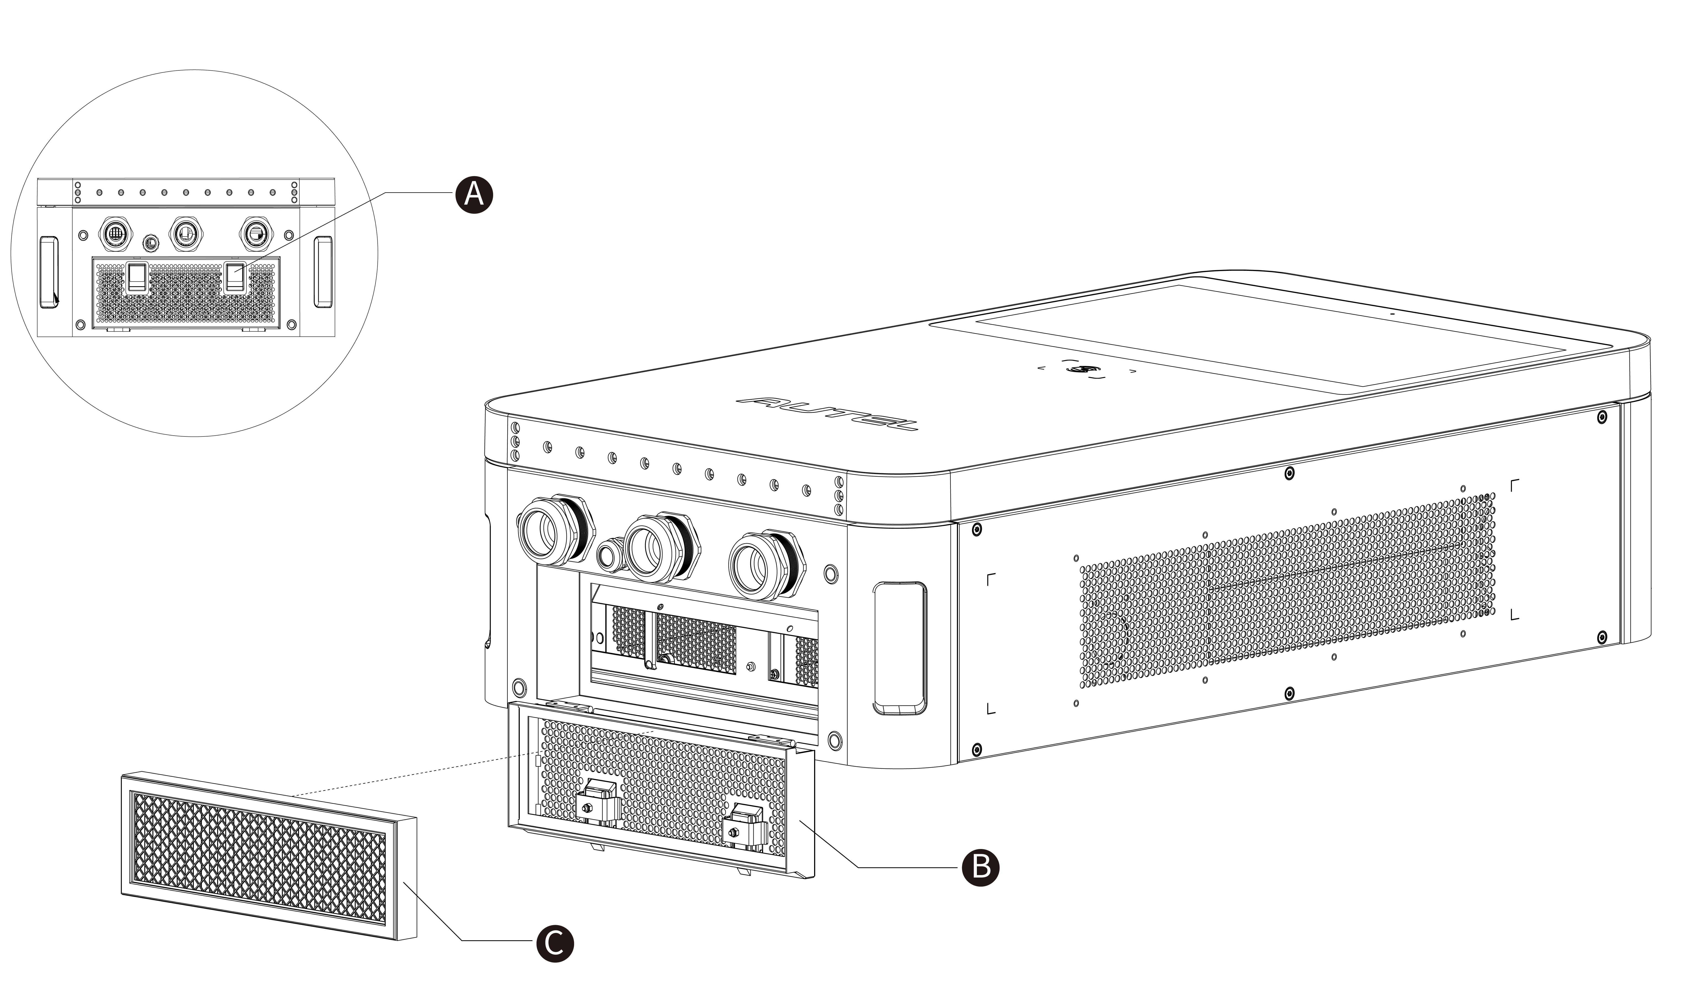

## Inspection and Maintenance

When the MaxiCharger operates normally, only routine maintenance is needed.

When the MaxiCharger operates abnormally, refer to Troubleshooting to resolve the problem or contact your local dealer or Autel Technical Support promptly.

When parts need to be replaced, completely cut off the power supply upstream and inside the equipment before operating.

Regularly conduct a visual inspection of the following points:

* Cable and connector: Check for cracks or ruptures on the connector or cable.
* Display: Check for damage and cracks. Check whether the touchscreen works.
* MaxiCharger coating: Check for damage, cracks or ruptures.
* MaxiCharger: Check for rust or damage.

The following special inspections are needed for safe use:

* Check if the MaxiCharger was struck by lightning.
* Check if the MaxiCharger was damaged due to an accident or fire.
* Check the MaxiCharger installation site has been flooded.

**WARNING**

Stop any charging processes and do not connect the power to the MaxiCharger until all the inspections are complete.

## Remote Maintenance

The MaxiCharger has the function of connecting to cloud platform to monitor parameters in real time. This provides remote upgrades, remote diagnosis, and remote service functions, and can timely identify and locate problems in the operation process.

* System self-check for abnormality daily.
* If any operation abnormality is found, contact your local dealer or Autel technical support promptly.
* Autel service engineers can check logs, update configurations and programs, and provide remote maintenance services, such as remote management, diagnosis, configuration, and upgrades.

## Maintenance Schedule

|  |  |  |
| --- | --- | --- |
| **Item** | **Frequency** | **Actions** |
| **Connector** | Every 3 months | Check for cracks or ruptures on the connector. |
| **Input Cable** | Every 3 months | Check for cracks or ruptures on the cable. |
| **Filter** | Annually | Replace the filter. |
| **MaxiCharger** | Every 3 months | Clean and check for damage. |

# Troubleshooting and Service

## Troubleshooting

1. Try to find a solution for the problem with the aid of the information in this document.
2. If you cannot find a solution for the problem, contact your local Autel representative or Autel Technical Support.

| Issue | Possible Cause | Solution | Handler |
| --- | --- | --- | --- |
| Screen Not Displaying | No power supply to the MaxiCharger. | Check the power supply to the upstream distribution box.  Open the front door and check the RCD breaker.  Use the mulitmeter to test the power input. | Customer Technical Support/  Autel Technical Support |
| The touchscreen displays a message: Unable to lock the connector. | The connector is not connected correctly to the EV. | Plug the connector into the EV charging port correctly and retry.  Try another MaxiCharger to charge the EV. | Customer Technical Support/  Autel Technical Support |
| The touchscreen displays a message: Insulation error detected. | There is an insulation problem on the EV or the MaxiCharger. | Try another MaxiCharger to charge the EV.  Contact Autel technical support. | Customer Technical Support/  Autel Technical Support |
| QR Code Scanning Failure | Cellular network failure | Ensure that the network SIM card is properly installed. | Customer Technical Support/  Autel Technical Support |
| Local network failure | Check local network connection. | Customer Technical Support/  Autel Technical Support |
| RFID Card Reading Failure | The RFID card is not recognized. | The RFID card broken.  No RFID card data on the cloud.  Use a new RFID card. | Customer Technical Support |
| Insufficient balance | Contact the operator for top-up. | Customer Technical Support |
| Internet failure | See "QR Code Scanning Failure" solutions above. | Customer Technical Support/  Autel Technical Support |
| Charging Failure | The connector is not properly connected. | Check the connector connection and reconnect it.  Try another MaxiCharger to charge the EV. | Customer Technical Support/  Autel Technical Support |
| EV error | Try another MaxiCharger to charge the EV.  Contact your EV manufacturer for support. | EV dealer/  EV manufacturer |
| Charger error | Try another MaxiCharger to charge the EV.  Contact Autel technical support. | Customer Technical Support/  Autel Technical Support |
| **Others** | Other issues | Contact Autel technical support. | Autel Technical Support |

## Service

If you cannot find solutions to your problems with the aid from the table above, please contact Autel Technical Support.

AUTEL Europe

* **Phone**: +49(0)89 540299608 (Monday–Friday, 9:00 AM–6:00 PM Berlin Time)
* **Email**: evsales.eu@autel.com; evsupport.eu@autel.com
* **Address**: Landsberger Str. 408, 4. OG, 81241 Munich, Germany



